**MEDICINE INVENTORY MANAGEMENT SYSTEM   
FOR SMALL PHARMACIES**

Capstone Project Presented to

CEDAR College, Inc.

National Highway

Cadiz City, Negros Occidental

In Partial Fulfillment of the

Requirements for the Degree of

Bachelor of Science in Information Technology

BY:

Christian Dominique A. Abella

Lhenel Ann Jaira L. Gallo

Ana Liza B. Masgon

Richel Mae J. Villa

March 2025

**APPROVAL SHEET**

This Capstone Project

**MEDICINE INVENTORY MANAGEMENT SYSTEM FOR SMALL PHARMACIES**

Prepared and submitted by Christian Dominique A. Abella, Lhenel Ann Jaira L. Gallo, Ana Liza B. Masgon, and Richel Mae J. Villa, is hereby recommended for approval and acceptance as a requirement for the degree:

**Bachelor of Science in Information Technology**

**JOHN DAVE A. BARILEA**

Capstone Adviser

Acceptance by the panel of Evaluators with a grade of __________.

**PANEL OF EVALUATORS**

**WILFREDO C. VILLANUEVA, PhD.**

Lead Panel

**ROMEO D. LOBATON, JR. JOHN PAUL B. PALMA**

Panelist Panelist

Approved as required for the degree of Bachelor of Science in Information Technology

**WILFREDO C. VILLANUEVA, PhD.**

School President

**ABSTRACT**

This study sought to create and implement the Medicine Inventory Management System for Small Pharmacies, a web-based system that facilitates the monitoring of inventory and sales for small pharmacies. The system has features such as inventory tracking, automated alerts for reorder levels, and monitoring of the medicine expiration dates. Additionally, it uses role-based access control, which ensures that unauthorized personnel do not modify inventory information, thus reducing the chances of fraudulent activity and poor management of stock.

Pharmacists and administrators from Cadiz City, Negros Occidental, took part in the functional test and user acceptability testing (UAT) of the system to determine its performance. The results indicate that the system users have noted an improvement in the accuracy of the inventories, there are fewer stockouts, and there are no sales of expired medications. Before the system's deployment, tracking inventory was subject to human errors, which created inefficiency and lost revenue. However, the technology has resulted in a positive shift in customer service, reduced human error, and improved speed of inventory reconciliation.

Overall, the System for Managing the Medicine Inventory for Small Pharmacies provides an innovative and efficient method of controlling pharmacy inventories, minimizing wastage in the pharmaceuticals, and improving operational processes.

*Keywords:*

*Automated Drug Inventory System along with Expiry Patrol, Role-Based Access Control, and Small Pharmacy Management.*

**TABLE OF CONTENTS**

**Title**

Title Page i

Approval Sheet ii

Abstract iii

Table of Contents iv

List of Tables vi

List of Figures vii

**CHAPTER I**

Introduction 1

Project Context 1

Project Description 2

Objectives 3

Significance of the Study 3

Scope and Limitation 4

Definition of Terms 5

Review of Related Literature 7

Conceptual Framework 13

**CHAPTER II**

Research Method 14

Locale of the Study 14

Theoretical Framework 15

Use Case Diagram 17

Requirements Cost 18

Labor Cost 18

Cost-Benefit Analysis 19

Return on Investment 20

Gantt Chart 21

System Prototype 22

Data Flow Diagram 26

Data Flow Diagram Level 0 27

Entity-Relationship Diagram 28

System Architecture 29

Program Evaluation and Review Technique 30

Critical Path Method 31

**CHAPTER III**

Presentation of Data 32

**CHAPTER IV**

Conclusion 48

Recommendations 48

References 50

Appendices 53

**List of Tables**

No. Page

1 Conceptual Framework 13

2 Requirements Cost 18

3 Labor Cost 18

4 Cost-Benefit Analysis 19

5 Gantt Chart 21

**List of Figures**

No. Page

1 Locale of the Study 14

2 Theoretical Framework 15

3 Use Case Diagram 17

4 System Prototype 22

14 Data Flow Diagram 26

15 Data Flow Diagram Level 0 27

16 Entity-Relationship Diagram 28

17 System Architecture 29

18 Program Evaluation and Review Technique 30

19 Critical Path Method 31

**CHAPTER I**

**INTRODUCTION**

**Project Context**

Small pharmacies play a critical role in providing local communities with access to essential medications. However, many of these pharmacies face significant challenges in inventory management and operational efficiency due to limited resources and outdated systems. These inefficiencies can lead to medication errors, stockouts, and other issues. Small pharmacies play a critical role in providing local communities with access to essential medications. However, many of these pharmacies face significant challenges in inventory management and operational efficiency due to limited resources and outdated systems. These inefficiencies can lead to medication errors, stockouts, and other operational issues, which can negatively impact business sustainability.

To address these challenges, the "Medicine Inventory Management System for Small Pharmacies" has been developed. This system is specifically designed for pharmacy administrators and staff to streamline inventory management processes, ensuring the availability of medications, reducing errors, and improving overall efficiency. The system includes features such as real-time inventory tracking, automated restocking alerts, and role-based access control, all of which enable pharmacies to manage their operations more effectively and enhance customer service.

The user-friendly interface ensures that pharmacy staff, regardless of technical expertise, can easily navigate and adopt the system. The "Medicine Inventory Management System" helps pharmacies optimize inventory management, improve operational performance, and provide better service to their customers, supporting long-term business sustainability.

**Project Description**

The "Medicine Inventory Management System" is a comprehensive solution designed to optimize the operations of small pharmacies. Tailored specifically for pharmacy administrators and staff,

The system offers tools to manage inventory efficiently, track stock levels, and maintain organized records, allowing pharmacy personnel to focus on essential tasks.

Key features of the system include real-time inventory monitoring, automated restocking notifications, and the ability to restore accidentally deleted medicines. These functionalities ensure that essential medications are always available and help minimize manual errors.

Additionally, the system incorporates a role-based access structure, where users can encode and delete medicines, while only administrators have access to all the system's functions, ensuring secure and controlled access to sensitive data.

With its user-friendly interface, the system is accessible to pharmacy staff with varying levels of technical expertise, ensuring ease of use and quick adoption. By addressing the specific needs of small pharmacies, the "Medicine Inventory Management System" enhances operational efficiency, improves customer service, and streamlines internal workflows.

**Objectives**

The primary objective of the "Medicine Inventory Management System" is to tackle the operational challenges encountered by small retail pharmacies. Furthermore, the specific objectives are as follows:

1. To develop a real-time inventory management system through a centralized dashboard, enabling pharmacies to monitor stock levels, add new medicines, and manage inventory efficiently, while also allowing the restoration of accidentally deleted medicines;
2. To establish a role-based access system, allowing users to encode and delete medicines, while ensuring that only the administrator has access to all dashboard functions, thereby ensuring secure and controlled access to the system.
3. To provide an efficient and user-friendly system that minimizes medication errors, ensures the availability of essential medicines, and enhances pharmacy operations to improve customer service and business sustainability.

**Significance of the Study**

The Medicine Inventory Management System for Small Pharmacies addresses key operational challenges specific to small pharmacy businesses. Its significance is outlined in the following areas:

**Small Pharmacies** - the system improves inventory management through real-time stock monitoring, automated alerts for low stock and expiration dates, and accurate tracking of stock movement. This reduces the risk of stockouts, prevents medication wastage due to expired products, and helps optimize stock levels.

**Pharmacy Staff** **-** the system simplifies tasks such as inventory updates and sales tracking. Its intuitive interface allows staff, regardless of technical expertise, to perform these tasks quickly and accurately, improving service speed and minimizing errors.

**Pharmacy Administrators -** the system provides role-based access control to secure sensitive data. Administrators can monitor inventory levels, track sales trends, and generate reports to identify inefficiencies. This enables informed decision-making for better inventory control and enhanced profitability.

**Customers** **-** the system ensures the availability of critical medications and the proper application, improving customer satisfaction and trust in the pharmacy’s services.

**Scope and Limitation**

The "Medicine Inventory Management System for Small Pharmacies" is designed to streamline inventory management and track stock levels in small pharmacies. It allows pharmacy staff to add new medicines, restore deleted items, and monitor expiration dates. The system also includes role-based access control to ensure secure usage and is easy for staff with varying technical expertise to adopt.

However, the system is limited to small pharmacies and does not integrate with advanced Point-of-Sale (POS) systems or larger enterprise platforms. It does not support multi-location management, automated inventory replenishment, or integration with external software. Additionally, the reporting tools offer basic analytics, which may not meet the needs of larger or more complex pharmacy operations.

**Definition of Terms**

**1. Medicine Inventory Management System**

A software solution designed to help small pharmacies track, manage, and optimize their inventory of medicines and healthcare products.

Operationally, this system automates inventory control, restocking alerts, and reporting functions to enhance operational efficiency and streamline pharmacy operations.

**2. Pharmacy**

A retail business that dispenses prescription and over-the-counter medications, as well as other health-related products, to customers.

Operationally, this refers to small-scale pharmacies that use the platform to manage inventory, sales, and other essential operational tasks.

**3. Inventory Management**

The process of overseeing the supply, storage, and usage of medications and healthcare products in a pharmacy.

Operationally, this includes tracking stock levels, placing orders, and managing product expiration to ensure medications are available without overstocking.

**4. Stock Levels**

The quantity of medications and health-related products available in a pharmacy at any given time.

Operationally, this involves real-time tracking and updating of stock levels to avoid stockouts or excess inventory.

**5. Automated Restocking Notifications**

A feature within the system that automatically notifies pharmacy staff when inventory levels fall below a predefined threshold.

Operationally, this feature ensures timely restocking to prevent medication shortages and maintain stock availability.

**6. Sales Tracking**

The process of recording and analyzing sales data to monitor product performance and sales trends.

Operationally, this feature logs each sale, generates sales reports, and helps pharmacies analyze trends to optimize inventory management and sales strategies.

**7. Reporting Tools**

Features that generate detailed reports on inventory, sales, and customer interactions.

Operationally, these tools enable pharmacy administrators to make informed decisions by providing insights into trends, sales performance, and operational efficiency.

**8. User Interface (UI)**

The design and layout of the system that allows users to interact with the platform.

Operationally, this refers to the visual elements, navigation, and controls that pharmacy staff use to perform tasks such as inventory tracking, sales management, and reporting.

1. **Expiry Tracking**

The process of monitoring the expiration dates of medications and healthcare products in the pharmacy’s inventory.

Operationally, this feature helps pharmacy staff track the shelf life of products, ensuring expired items are flagged and removed from the inventory to prevent dispensing expired medications.

**10. Role-Based Access Control**

A security feature that restricts system access based on user roles and permissions.

Operationally, this ensures that only authorized personnel can perform specific tasks, such as inventory updates, sales transactions, and administrative functions, enhancing data security and operational control.

**Review of Related Literature**

Aldrin Nico R. Plantado, et al. (2023) describe the establishment and functioning of an online telepharmacy service in the Philippines, analyzing its usage and examining the health information-seeking behaviors of users during the COVID-19 pandemic. The service employed multiple platforms for query handling, communication, and marketing. Data collected from submissions between March 20 and May 31, 2020, were analyzed, focusing on parameters such as submission timing, response rates, user feedback, demographic details, and inquiry subjects. In the context of the "new normal," it is crucial to embrace alternative platforms to complement traditional health information sources. An online telepharmacy service can significantly contribute to delivering and clarifying medication-related information as part of primary healthcare.

According to Alvin Gino M. Bautista (2020), a study aimed at evaluating the financial management practices of small-scale pharmacy owners in Cabanatuan City, Philippines, specifically focused on cash flow and accounts payable management. The research encompassed 16 small pharmacies located near government hospitals, such as Dr. Paulino J. Garcia Memorial Research Center, Manuel V. Gallego, Cabanatuan City Hospital, and Eduardo L. Joson Provincial Hospital. This study included both sole proprietorships and partnerships, while excluding corporate pharmacies in the vicinity. The outcomes of this research are significant for small pharmacy owners, as they provide insights into effective management strategies that can enhance efficiency in handling cash and accounts payable. The study’s recommendations aim to improve the financial management techniques of small pharmacy businesses.

In addition, Caterina Cavicchi and Emidia Vagnoni (2020) discuss the increasing demand for community pharmacies to contribute to sustainable healthcare systems by engaging in integrated care models and taking on significant educational responsibilities in environmental conservation. These developments have resulted in heightened competition in the retail pharmaceutical sector and a shift toward a service-oriented business framework. Such changes necessitate a reevaluation of the business models of these hybrid organizations, which blend profit-driven, social, and environmental objectives. The paper presents a sustainable business model (SBM) that enables community pharmacies to enhance public health through their existing roles and the expansion of those roles. The COVID-19 pandemic underscores the importance of prioritizing human health within the sustainable development agenda and raises questions about extending patient-oriented services provided by community pharmacies. The SBM presents an opportunity for community pharmacies to strengthen their position within the healthcare workforce, particularly in times of global health crises. Additionally, the SBM supports the incorporation of sustainability into everyday pharmacy practices, though it requires customization to fit the unique context of each business, considering health policies and regulations in various countries.

Eric Parilla, et al. (2022) investigates the connection between inventory management strategies and service delivery in healthcare facilities across Ilocos Norte, Philippines. The research included 16 healthcare establishments and surveyed 80 patients, chosen through a convenience sampling method. Utilizing a quantitative research framework and a causal research approach, the study aimed to explore the relationship between the independent and dependent variables. It identified five primary inventory management practices: pharmacy premises and storage, drug information, safety and security, personnel and stock control, and monitoring. Hospitals were evaluated on service quality across four areas: admissions, treatment, environment and facilities, and discharge processes. The results indicated a significant correlation between personnel and stock control, monitoring, and overall service quality. The study also offered implications, conclusions, and suggestions for improvement.

Frances Lois U. Ngo, et al. (2024) highlights the pivotal role of community pharmacists as healthcare professionals with direct access to patients during the COVID-19 pandemic. However, prior research documenting the challenges, adaptive strategies, and opportunities faced by community pharmacy practice in the Philippines during this time is scarce. This study seeks to outline the difficulties encountered by community pharmacists, the adaptive measures they adopted, and the opportunities to improve community pharmacy practices that arose due to the pandemic. The identified challenges led to various adaptive strategies, further underscoring the vital function of community pharmacists in the healthcare system.

John A. Dougherty (2020) describes how the Gregory School of Pharmacy developed a co-curricular program designed to enhance both didactic and experiential learning while adhering to the standards set by the Accreditation Council for Pharmacy Education (ACPE). The program aims to improve student learning outcomes, provide constructive feedback, document the achievement of learning objectives, and track student progression. In 2016, the faculty at Samford-McWhorter recognized the necessity to update the Doctor of Pharmacy curriculum to better prepare graduates for the evolving landscape of pharmacy practice and healthcare. A faculty-led Curricular Transformation Task Force organized retreats, implemented workgroups, and crafted a comprehensive curricular framework. The Assessment Committee established program competencies based on endorsed documents from the academy, including CAPE, EPAs, IPEC, and ACPE standards. Furthermore, both the Curriculum and Assessment Committees devised a quality assurance model to oversee the curriculum's implementation each year. Following extensive collaboration, which involved debates, retreats, meetings, and discussions, the faculty approved a new 146-credit-hour curriculum. Incoming students starting in the fall 2020 semester will embark on this new curriculum, thereby advancing pharmacy education and the profession.

Kevin Chu and Juan Manuel Martínez Pizano (2019) note that pharmaceuticals represent a substantial portion of global healthcare spending, making effective inventory management vital for the financial stability of the retail pharmaceutical industry. The retail pharmacy examined in this study faced challenges associated with managing high-performance inventory strategies. The analysis utilized descriptive analytics, such as demand frequency, variability, and profit, alongside data mining and quantitative models, including inventory control, sensitivity analysis, and scenario analysis. These methodologies aimed to identify optimal replenishment strategies for a prioritized group of SKUs, factoring in elements such as forecast duration, stock-out penalties, and customer service levels. The findings reveal the trade-off between taking advantage of supplier discounts and incurring higher costs associated with excess inventory, as well as the need to balance holding costs with stock-out penalties. The research recommends employing the (Q, R) policy for high-profit SKUs, which could achieve an average cost reduction of 33%, and the (s, S) policy for low-profit SKUs, leading to a potential 37% cost reduction.

Paul M. Reynolds, et al. (2020) assert that clinical capstone courses are essential for enhancing skills within healthcare education. Nonetheless, there is limited literature regarding the successful implementation of distance-based clinical capstone courses, particularly for pharmacists practicing worldwide. These courses aim to bolster key competencies and prepare students for experiential rotations, although their effect on student confidence in critical areas remains underexplored. This educational cohort study assessed whether a distance-based clinical capstone course could enhance student confidence in crucial competencies for success in advanced pharmacy practice experiences (APPEs). The course incorporated diverse learning strategies, such as longitudinal case discussions, standardized patient interviews, and drug information inquiries. The primary objective was to strengthen students' critical thinking, clinical decision-making, problem-solving abilities, and readiness for APPEs by utilizing increasingly complex case scenarios and promoting student-driven learning. Surveys were administered at various stages to evaluate changes in confidence throughout the course.

Soetkin Deschepper (2021) indicates that Belgian hospitals have been mandated to collaborate within locoregional networks since January 1, 2020. This collaboration presents an opportunity for hospitals to share services, such as establishing centralized hospital pharmacies. The study aimed to evaluate the operational feasibility of organizing a centralized hospital pharmacy to oversee the drug distribution process across a network of hospitals. A case study was conducted using a literature review and interviews with a Belgian best practice network, GZA-ZNA. The assessment of operational feasibility for centralizing the hospital pharmacy within the E17-network was conducted through semi-structured interviews with seven chief pharmacists and one pharmacist involved in network projects. To enhance the quality and external validity of the research, insights from the vision document of Zorgnet-Icuro were also included, with further clarification obtained through an interview. While the vision document outlined the fundamental needs for centralizing hospital pharmacies across Belgian networks, the case study specifically focused on identifying opportunities, challenges, and prerequisites for centralization within the E17-network.

Venice Lara Soliveres, et al. (2024) emphasize that effective inventory management is crucial for pharmacies, ensuring the constant availability of pharmaceutical products while minimizing the risk of stockouts or overstock situations, thereby enhancing customer satisfaction. This study aimed to evaluate the inventory management practices of small-scale pharmacies in selected towns in Cavite, Philippines. The researchers utilized a descriptive research approach and purposive sampling, including 50 legally registered small pharmacies as participants. The results indicated that most pharmacies were sole proprietorships, employing between one and nine staff members, with estimated assets of P3,000,000 or less. They had been in operation for either one to three years or ten years and beyond. The study provides valuable insights that could serve as a foundation for small-scale pharmacies to refine their inventory management practices. It offers suggestions for improving existing methods related to sourcing, storing, and selling, thereby enhancing the monitoring and control of inventory movements from acquisition to transaction.

****Conceptual Framework****

|  |  |  |
| --- | --- | --- |
| **INPUT** | **PROCESS** | **OUTPUT** |
| * Pharmacy Inventory Data * Sales Transactions * Supplier Information * User Information | * Inventory Management * Sales Management * Supplier Management * User Management | * Updated Inventory Records * Sales Receipts * Supplier Orders * User Activity Log |

****Table 1. Input-Process-Output (IPO) Model****

**Input The system collects data such as pharmacy inventory details, sales transactions, supplier information, and user data. This data is essential for tracking stock levels, processing sales transactions, managing supplier relationships, and controlling user roles. It ensures that accurate and up-to-date information is available for effective system operations.**

****Process**  The system processes input data by managing inventory, sales, suppliers, and users, and generating reports. It tracks stock levels, records sales transactions, orders supplies when needed, and controls user access. Additionally, it produces reports that help in decision-making and operational improvements.**

**Output The system produces updated inventory records, sales receipts, supplier orders, reports, and user activity logs. These outputs maintain accurate stock levels, provide proof of transactions, track orders, and monitor system activity. The outputs enable pharmacy administrators to analyze performance, optimize inventory, and ensure the security of operations.**

**CHAPTER II**

**METHODOLOGY**

**Research Method**

The Medicine Inventory Management System for Small Pharmacies uses a qualitative and descriptive research approach to understand the experiences and challenges faced by pharmacy admins and staff in managing inventory. The study collects feedback on important features such as inventory tracking, stock management, supplier coordination, and report generation through interviews, focus groups, and usability tests. This research helps better understand how users interact with the system, identify their needs and challenges, and guide improvements to make the system more efficient and user-friendly for pharmacy operations.

**Locale of the Study**

The research will be conducted at Magsaysay St., Cadiz City, Negros Occidental, Philippines. The figure below shows a location map of JTT Pharmacy on Magsaysay St., Barangay Zone 3, Cadiz City, Negros Occidental, where the research will take place.





JTT Pharmacy

JTT PHARMACY

**Figure 1. JTT Pharmacy Location**

JTT Pharmacy

**Theoretical Framework**

Design

Requirements

Development

Testing

Deployment

Maintenance

**Figure 2. Waterfall Model**

The Medicine Inventory Management System for Small Pharmacies uses the Waterfall model, a structured and sequential approach to system development. The process begins by gathering user requirements, focusing on core features such as inventory management, stock tracking, and supplier coordination. Each phase—requirements, design, development, testing, deployment, and maintenance—is completed in a linear fashion to ensure the system effectively meets the needs of pharmacy administrators and staff.

**Requirements Phase**  Information is gathered from pharmacy administrators and staff to define essential features, such as inventory tracking and stock alerts, which guide the development process.

**Design Phase**

In this phase, the system’s structure and layout are designed based on the gathered requirements. This includes designing the user interface, selecting the technologies to be used (such as programming languages and database), and planning the overall system architecture. The design phase ensures the system is user-friendly and meets all functional needs.

**Development Phase**

The system is built according to the design specifications, with features such as inventory management and user access controls implemented.

**Testing Phase**

The system undergoes rigorous testing to identify and fix bugs, ensure all features work as intended, and verify that it meets the requirements. Testing checks the system's functionality, security, and performance under different conditions to ensure reliability before launch.

**Deployment Phase**

After testing, the system is deployed for use by pharmacy staff, with the server and database configured for daily operations.

**Maintenance Phase**

After deployment, the system is maintained by fixing bugs, applying updates, and ensuring it remains secure and aligned with the evolving needs of the pharmacy.

**Use Case Diagram**

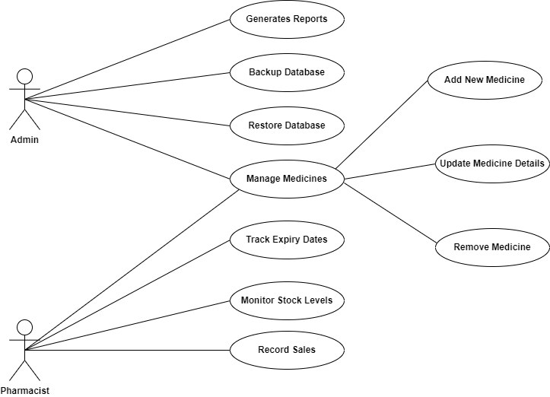

**Figure 3. Use Case Diagram**

**Requirement Cost**

|  |  |  |
| --- | --- | --- |
| Description | Admin | User |
| 1. **HARDWARE REQUIREMENTS** |  |  |
| * Laptop (11th Gen Intel® Core(TM) i5-1155G7 @ 2.50GHz 2.50 GHz, RAM 8.00 GB) | ₱30,000 | ₱0 |
| * Server Computer (Intel Core I5 16GB 512 SSD) | ₱42,000 | ₱0 |
| 1. **SOFTWARE REQUIREMENTS** |  |  |
| * Python Flask | ₱0 | ₱0 |
| * Operating System (Windows 11) 64-bit operating system, x64-based processor | ₱10,000 | ₱0 |
| * Database Management System (SQLITEL) | ₱0 | ₱0 |
| * Programming Language (PHP, HTML5, CSS5, and Javascript | ₱0 | ₱0 |
| * IDE/Development Tools (Visual Studio Code) | ₱0 | ₱0 |
| * XAMPP control panel | ₱0 | ₱0 |
| 1. **NETWORK REQUIREMENTS** |  |  |
| * LAN/WI-FI (Fiber Home) | ₱6,000 | ₱0 |
| 1. **INTEGRATION REQUIREMENTS** | ₱0 |  |
| * Version Control (Github) | ₱0 | ₱0 |
| **TOTAL COST** ₱88,000 ₱0 | | |

**Table 2. Requirements Cost**

**Labor Cost**

|  |  |
| --- | --- |
| **Peopleware** | **Cost** |
| Full Stack Developer | ₱40,000 |
| Data Encoder | ₱20,000 |
| System Administrator | ₱40,000 |
| QA Tester | ₱25,000 |
| Technical Support Staff | ₱20,000 |
| Pharmacist Consultant | ₱30,000 |

**Table 3. Labor Cost**

**Cost-Benefit Analysis**

|  |  |  |  |  |  |  |  |  |
| --- | --- | --- | --- | --- | --- | --- | --- | --- |
| **Item** | **Year 0** | **Year 1** | **Year 2** | **Year 3** | **Year 4** | **Total Cost** | **Total Benefits** | **Net Benefit/Cost** |
| Development Cost | ₱114,295 | - | - | - | - | ₱114,295 | - | - |
| Operational Cost | - | ₱52,540 | ₱52,540 | ₱52,540 | ₱52,540 | ₱210,160 | - | - |
| Maintenance Cost | - | ₱3,000 | ₱3,000 | ₱3,000 | ₱3,000 | ₱12,000 | - | - |
| **TOTAL COST** | ₱114,295 | ₱55,540 | ₱55,540 | ₱55,540 | ₱55,540 | ₱336,455 | - | - |
| PV Factor (10%) | 1.000 | 0.909 | 0.826 | 0.751 | 0.683 | - | - | - |
| Present Value | ₱114,295 | ₱50,486 | ₱45,876 | ₱41,711 | ₱37,933 | ₱290,301 | - | - |
| **TOTAL BENEFITS** | - | ₱110,000 | ₱115,000 | ₱125,000 | ₱130,000 | - | ₱480,000 | - |
| PV Factor (10%) | 1.000 | 0.909 | 0.826 | 0.751 | 0.683 | - | - | - |
| Present Value | - | ₱99,990 | ₱94,990 | ₱93,875 | ₱88,790 | - | ₱377,645 | - |
| **Net Cash Flow** | -₱114,295 | ₱54,460 | ₱59,460 | ₱69,460 | ₱74,460 | - | ₱143,545 | ₱143,545 |

**Table 4. Cost-Benefit Analysis**

**Return on Investment**

Total Cost 290,301

Total Benefit 377,645

Formula for Calculating the ROI:

ROI%= Total Benefits- Total Cost

X100

Total Cost

ROI%= Net Return

X100

Total Cost

ROI=377,645-290,301

X100

290,301

ROI=87,344

X100

290,301

X100

ROI= 0.3008739205169

30.09%

Return of Investment =

**Gantt Chart**

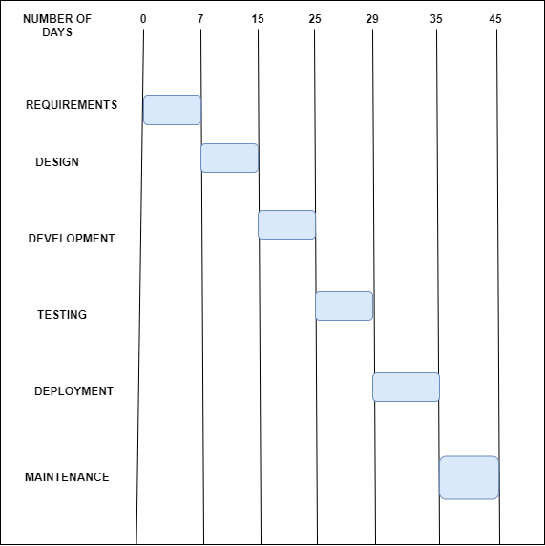

**Table 5. Gantt Chart**

**System Prototype**

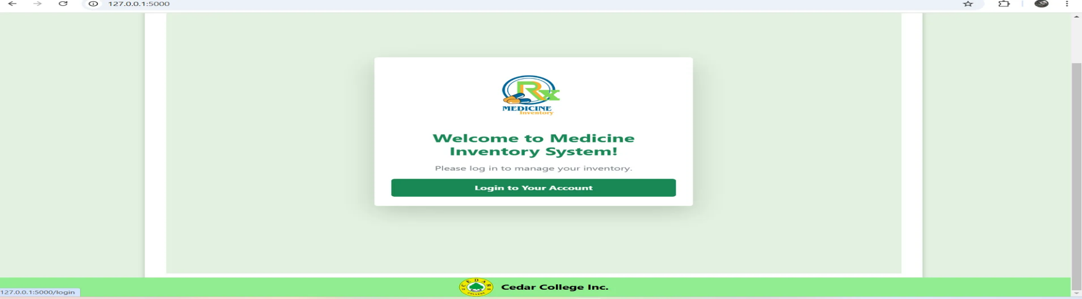

**Figure 4. Link to Log in Page**

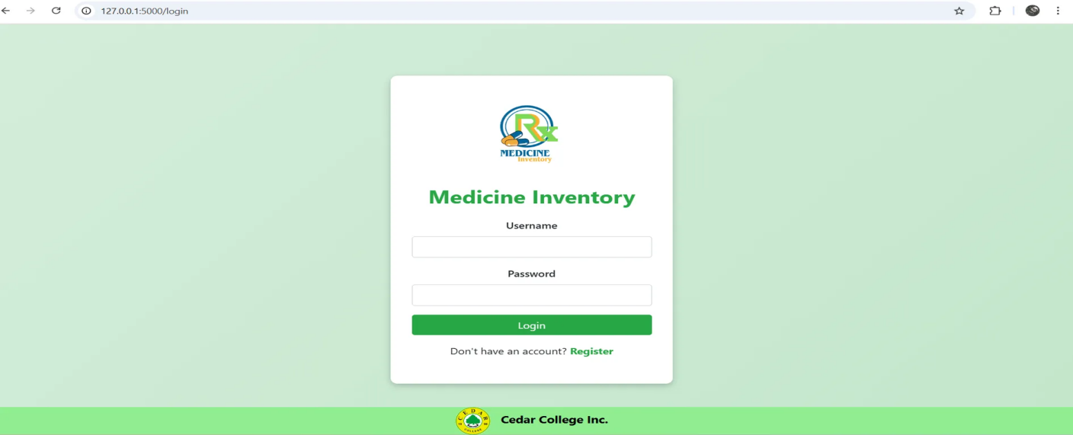

**Figure 5. Log in Page**

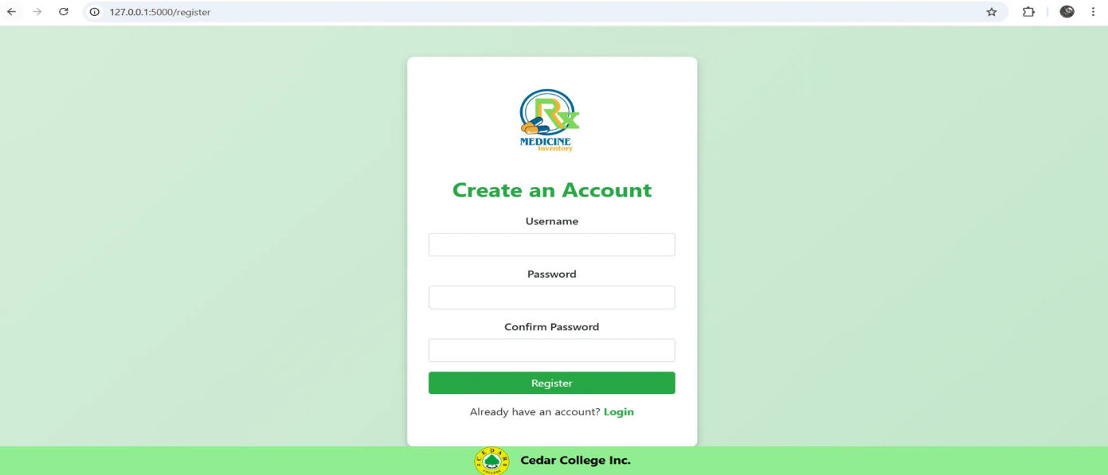

**Figure 6. Register Page**

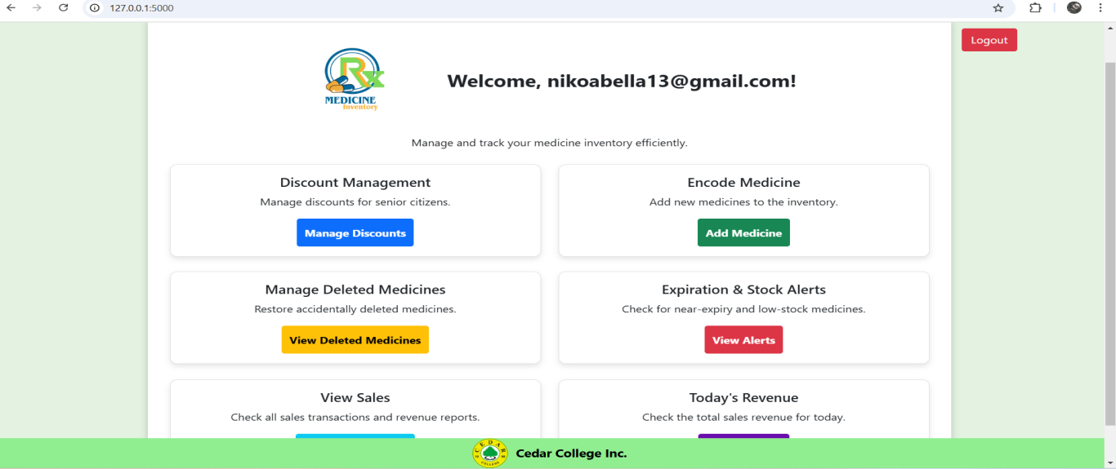

**Figure 7. Dashboard**

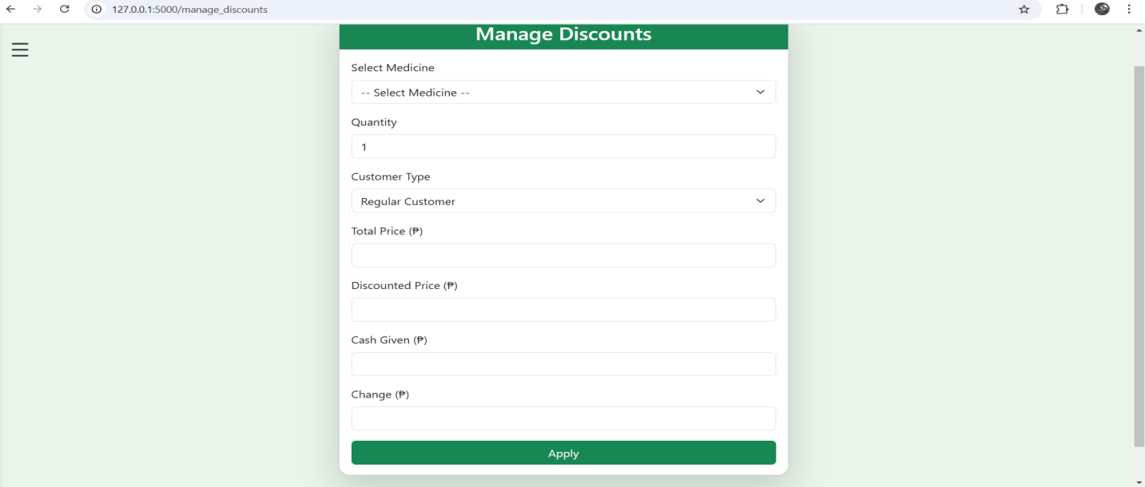

**Figure 8. Manage Discount Page**

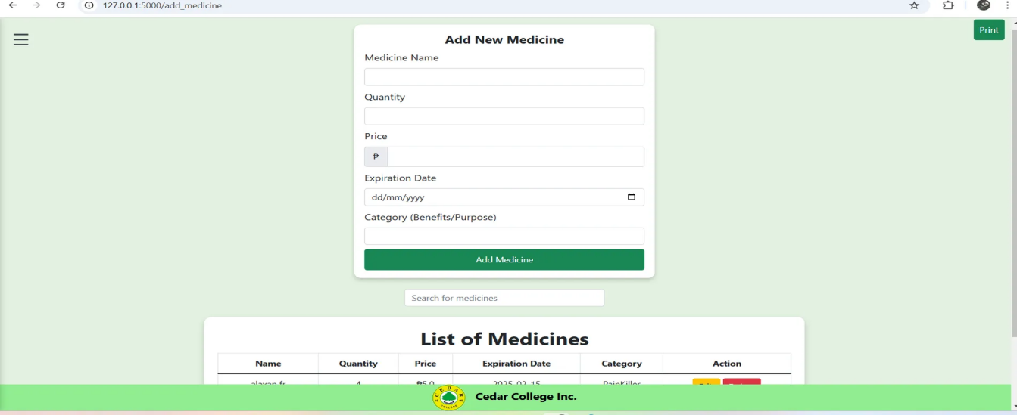 **Figure 9. Add Medicines Page**

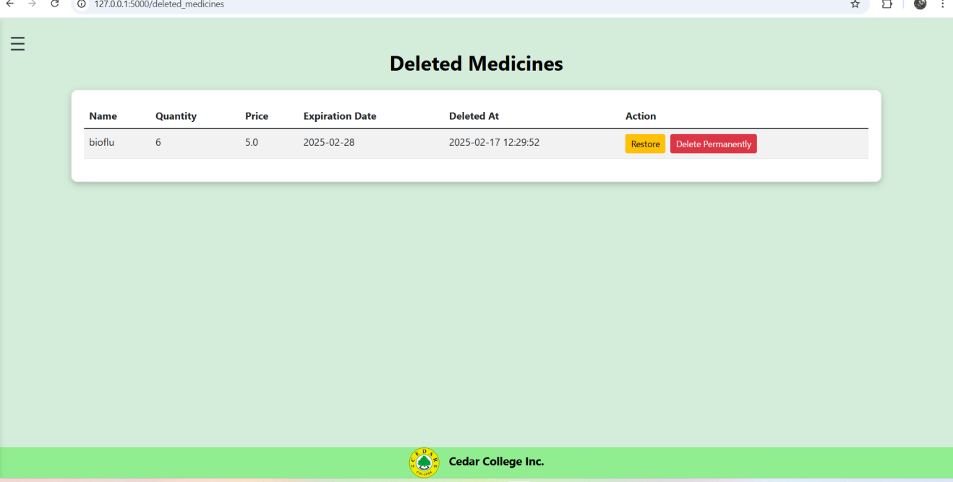

**Figure 10. View Deleted Medicines Page**

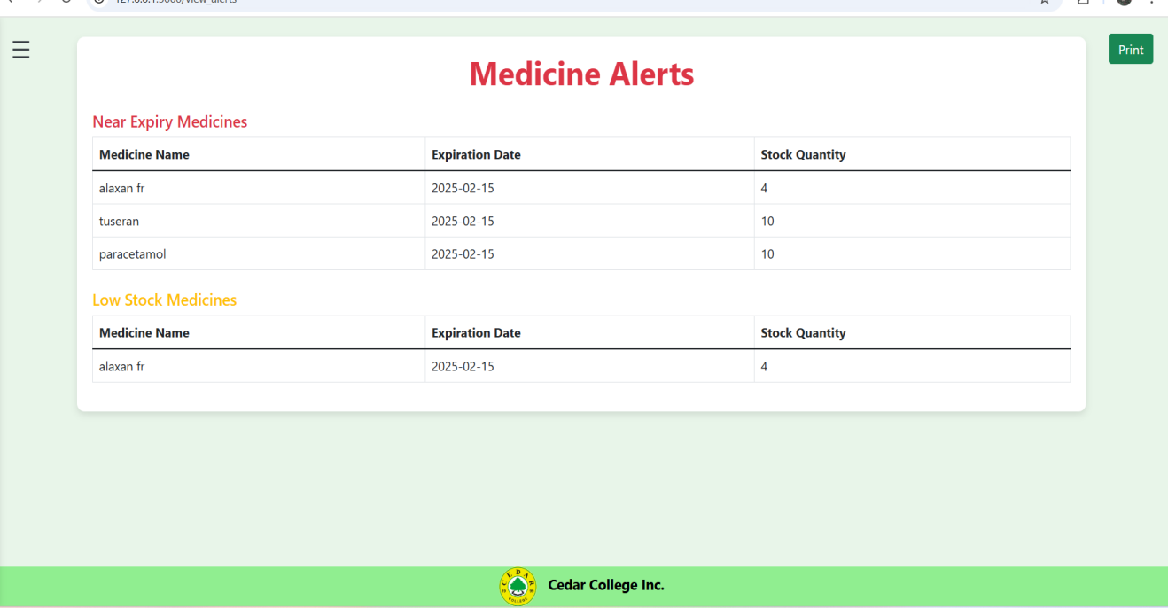

**Figure 11. View Alerts Page**

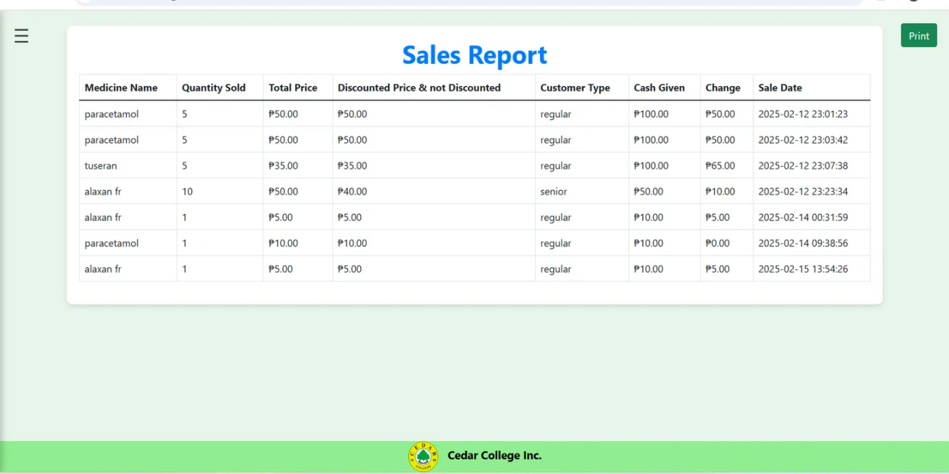 **Figure 12. View Sales Report Page**

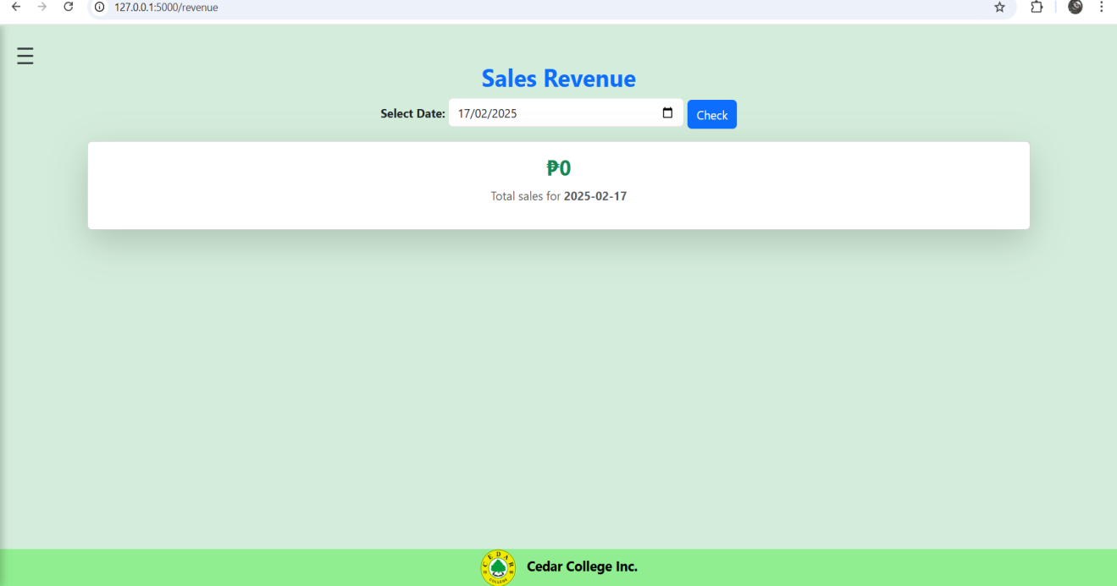

**Figure 13. View Sales Revenue Page**

**Data Flow Diagram**

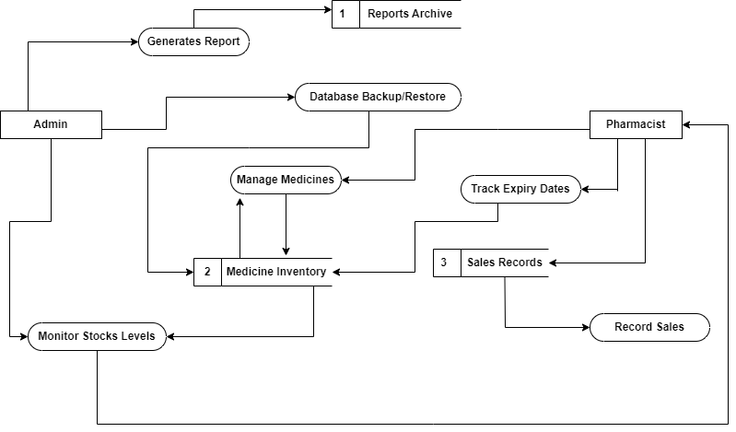

**Figure 14. Data Flow Diagram**

**Data Flow Diagram Level 0**

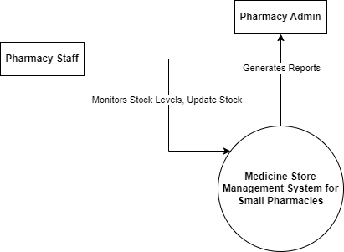

**Figure 15. Data Flow Diagram Level 0**

**Entity-Relationship Diagram**

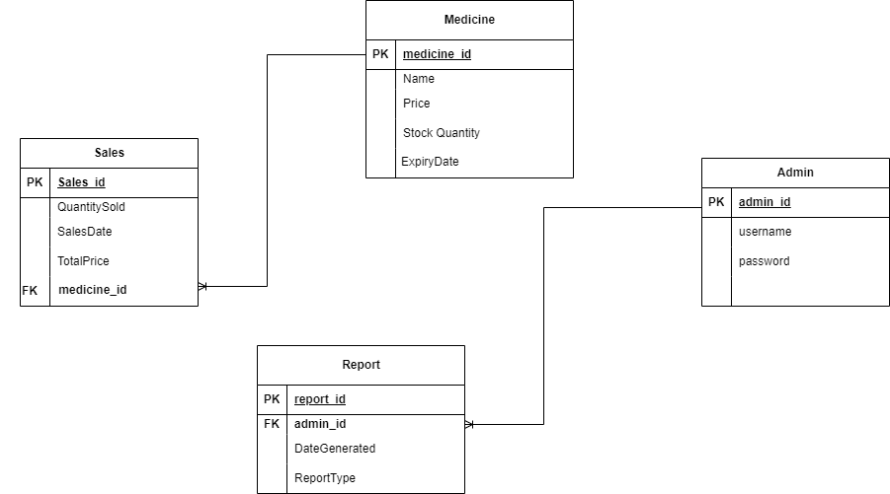

**Figure 16. Entity-Relationship Diagram**

**System Architecture**

The Medicine Inventory Management System for Small Pharmacies employs a layered architecture to ensure functionality, scalability, and security. This structure supports real-time inventory tracking, enabling accurate monitoring of stock levels while alerting staff about low supplies or approaching expirations. The system also includes analytics tools to provide insights into inventory trends and supplier performance, helping pharmacy administrators make informed decisions. This architecture delivers a secure and efficient platform tailored to pharmacy administrators and staff, streamlining inventory management processes.

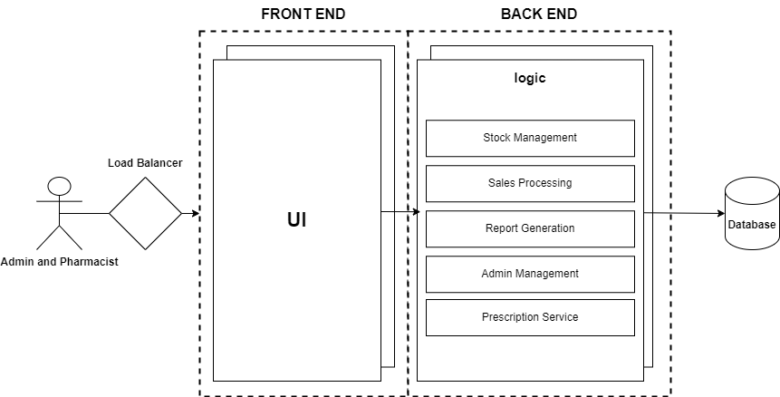

**Figure 17. Layered Architecture**

**Program Evaluation Review Technique**

7

0

0

7

A

Requirements

15

7

Design

B

15

7

25

155

15

Development

C

25

29

25

D

Testing

25

29

29

35

E

Deployment

29

35

35

45

F

Maintenance

35

45

**Figure 18. Program Evaluation Review Technique (PERT)**

**Critical Path Method**

B

A

C

D

E

F

Total No. Of Days: 45 Days

Critical Path: A, B, C, D, E, F

**Figure 19. Critical Path Method (CPM)**

**CHAPTER III**

**PRESENTATION OF DATA**

A survey was conducted during the requirements gathering phase to support the development of the Medicine Inventory Management System for Small Pharmacies. This platform is designed to provide small pharmacies with efficient tools to manage inventory, streamline daily operations, and improve overall business performance.

Feedback was gathered from 15 respondents, consisting of 4 males (26.67%) and 11 females (73.33%), to evaluate the proposed features of the platform.

The questions were aligned with the ISO/IEC 25010 standard, and responses were collected using a Likert scale with the following options: Strongly Agree, Agree, Neutral, Disagree, and Strongly Disagree.

This feedback is essential for refining the system's design and functionality to meet the specific needs of its intended users. The data gathered highlights user preferences, expectations, and potential areas of improvement, ensuring that the platform aligns with operational requirements and supports effective pharmacy management.

Neutral

Agree

Strongly Agree

Strongly Disagree

Disagree

**Figure 1. Responses on Functional Suitability of the Medicine Inventory Management System**

The majority of respondents (73.3%) strongly agreed, and 20% agreed, indicating that most participants found the system features functional and promising. However, 6.7% strongly disagreed, suggesting potential concerns that need to be addressed for full acceptance.

The platform is projected to have high acceptance in terms of functional suitability, with positive feedback from most users. To ensure broader acceptance, it is recommended to address the concerns raised by the 1 respondent who disagreed, possibly by refining specific features or providing additional training and support.

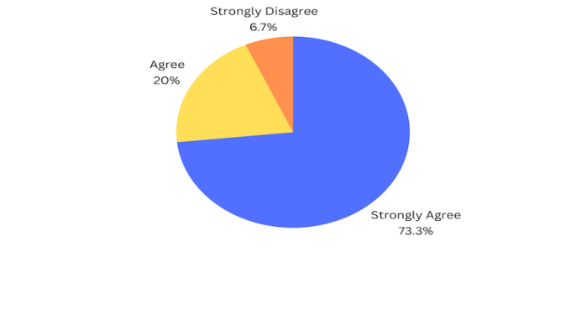

**Figure 2. Responses on Ease of Navigation of the Medicine Inventory Management System**

The results indicate that 9 out of 15 respondents (60%) strongly agreed, and 5 respondents (33.3%) agreed, reflecting an overall positive sentiment. Only 1 respondent (6.7%) strongly disagreed, highlighting minimal skepticism regarding the system ease of use.

The platform is projected to have high acceptance regarding ease of navigation. Addressing the concerns of the respondent who disagreed will help improve overall user satisfaction.

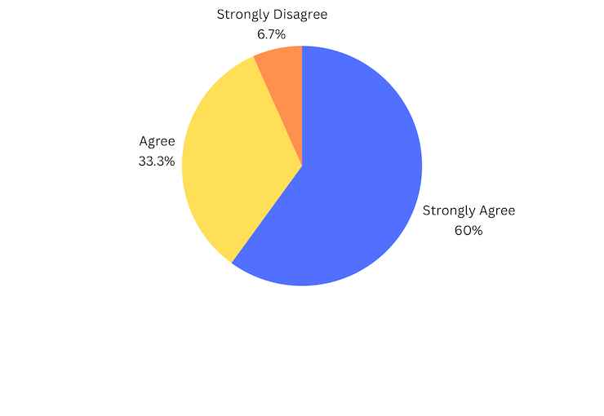

**Figure 3. Responses on Seamless Inventory Tracking**

According to the survey, 8 respondents (50%) strongly agreed, and 4 respondents (31.3%) agreed, showing confidence in the system’s tracking capabilities. However, 2 respondents (12.5%) were neutral, and 1 respondent (6.3%) strongly disagreed, indicating some reservations.

The platform is expected to perform well in inventory tracking. However, addressing the concerns of neutral and disagreeing respondents will be necessary to refine the system and boost user confidence.

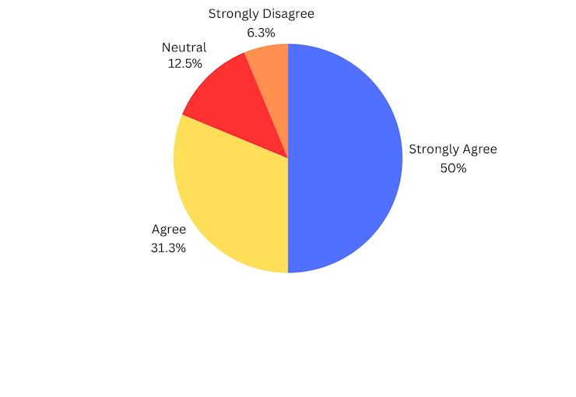

**Figure 4. Responses on Managing Inventory and Staff Operations**

The data reveals that 8 respondents (53.3%) strongly agreed, and 6 respondents (40%) agreed, while only 1 respondent (6.7%) strongly disagreed. This indicates that the majority of participants are confident in the platform’s ability to effectively manage inventory and streamline staff operations.

The platform is expected to perform well in assisting pharmacy admins and staff with operational management. To further improve user satisfaction, it is important to address the concerns raised by the respondent who disagreed.

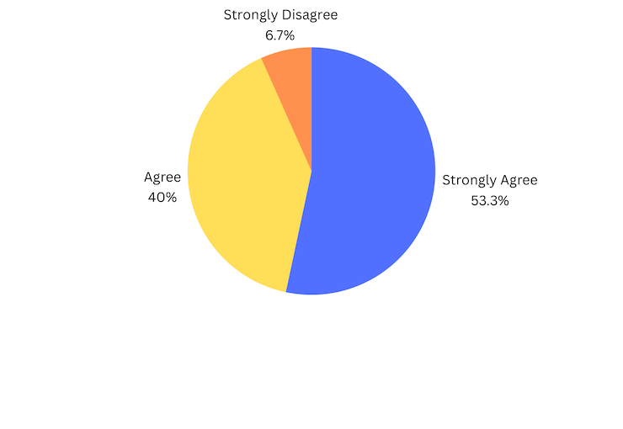

**Figure 5. Responses on Performance Efficiency**

As shown in the figure, 6 respondents (42.9%) strongly agreed, and 5 respondents (35.7%) agreed, while 3 respondents (14.3%) were neutral, and 1 respondent (7.1%) strongly disagreed. This highlights a generally positive perception, with some uncertainty about performance consistency.

The system is expected to be well-received in terms of performance efficiency. Addressing the concerns of neutral and disagreeing respondents will be essential for improving consistency and user confidence.

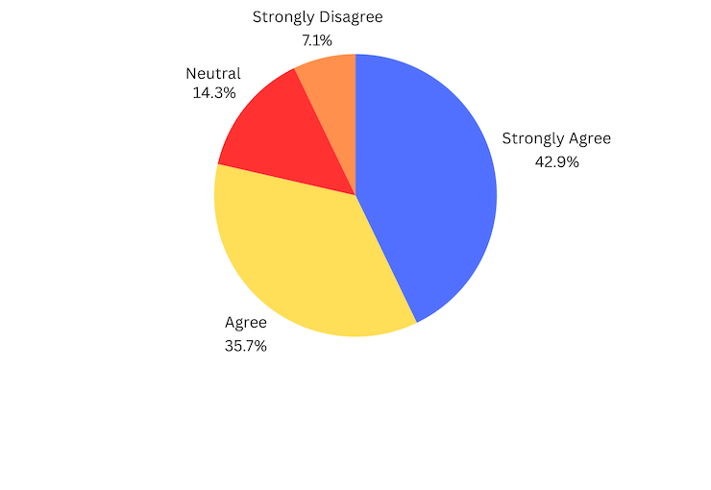

**Figure 6. Responses on Integration with Inventory and Pharmacy Operations**

As shown in the figure, 6 respondents (33.3%) strongly agreed, and 5 respondents (33.3%) agreed, while 3 respondents (20%) were neutral, and 1 respondent (6.7%) strongly disagreed. This indicates a generally positive perception, with some uncertainty regarding the integration of the system with inventory and pharmacy operations.

The platform is expected to be well-received in terms of improving inventory management and pharmacy operations. To enhance consistency and address user concerns, it is important to focus on the feedback from the neutral and disagreeing respondents.

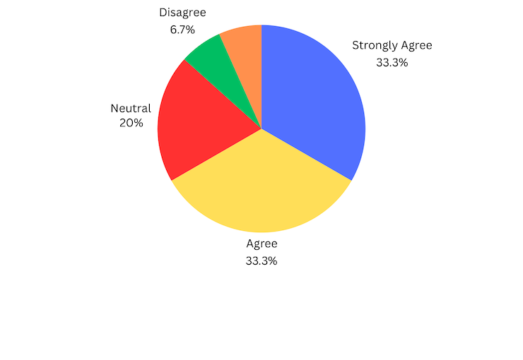

**Figure 7. Responses on Flexibility in Handling Stock and Product Variety**

According to the figure, 6 respondents (40%) strongly agreed, and 5 respondents (33.3%) agreed, while 3 respondents (20%) were neutral. Only 1 respondent (6.7%) strongly disagreed, indicating general confidence with minor concerns.

The platform is projected to be successful in handling stock and product variety. However, addressing the concerns raised by the single respondent who disagreed will improve its flexibility.

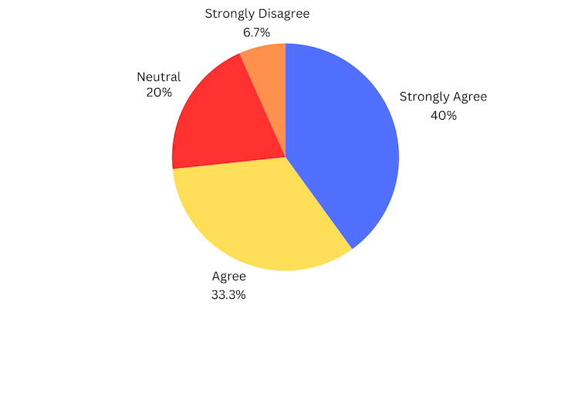

**Figure 8. Survey Responses on Supporting Pharmacy Admin and Staff Expectations**

The results show that 8 respondents (53.3%) strongly agreed, and 6 respondents (40%) agreed, with 1 respondent (6.7%) selecting neutral. This indicates strong confidence in the platform’s ability to meet the needs of pharmacy administrators and staff.

The platform is expected to effectively support pharmacy operations. Attention should be given to the neutral response to ensure full satisfaction and enhance user experience.

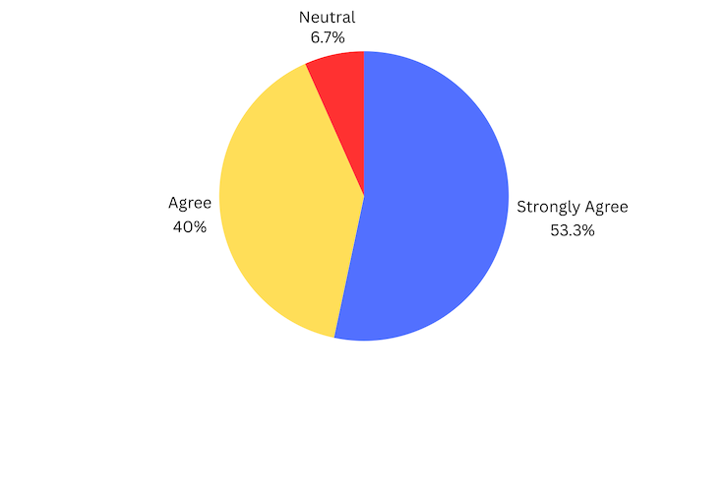

**Figure 9. Survey Responses on Data Reporting for Decision-Making**

The figure reveals that 8 respondents (53.3%) strongly agreed, and 5 respondents (33.3%) agreed, while 2 respondents (13.3%) were neutral. This indicates a generally positive outlook, with some opportunities for improvement in the reporting features.

The platform is expected to perform well in data reporting. Enhancing the reporting features and addressing the concerns of neutral respondents will further improve decision support for pharmacy administrators and staff.

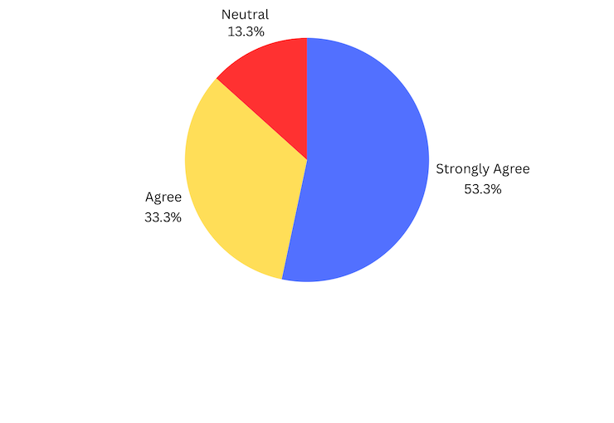

**Figure 10. Survey Responses on Efficient Stock Tracking**

As shown in the figure, 8 respondents (53.3%) strongly agreed, and 5 respondents (33.3%) agreed, while 2 respondents (13.3%) were neutral. This demonstrates high confidence in the system’s stock tracking capabilities.

The platform is projected to perform well in stock tracking. To further increase user confidence, addressing the neutral responses will help improve tracking performance.



**Figure 11. Survey Responses on Reliable Inventory Management**

As indicated, 6 respondents (40%) strongly agreed, and another 6 respondents (40%) agreed, while 2 respondents (13.3%) were neutral. Only 1 respondent (6.7%) strongly disagreed, reflecting a generally positive perception with slight skepticism.

The platform is expected to perform well in inventory management. Addressing the concerns of the respondent who disagreed will help improve overall trust in the system.

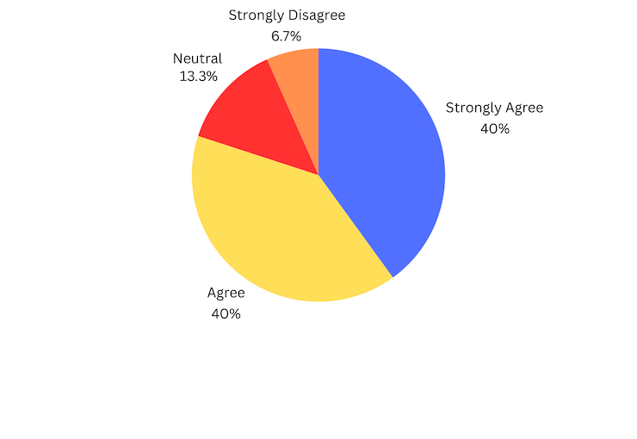

**Figure 12. Survey Responses on Minimizing Disruptions from Errors**

The figure highlights that 6 respondents (40%) strongly agreed, and another 6 respondents (40%) agreed. However, 1 respondent (6.7%) was neutral, and 2 respondents (13.3%) strongly disagreed, pointing to the need for error reduction.

The platform is expected to minimize disruptions caused by errors. However, addressing the concerns raised by the respondents who disagreed will be necessary for improving overall performance.

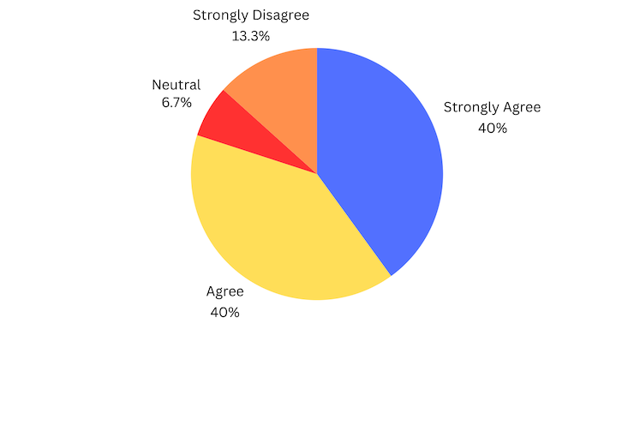

**Figure 13. Survey Responses on Security Features**

The survey shows that 5 respondents (33.3%) strongly agreed, and 6 respondents (40%) agreed, while 3 respondents (20%) were neutral, and 1 respondent (6.7%) strongly disagreed. This highlights the need to emphasize robust security measures.

The platform is expected to be well-received for its security features. To enhance user confidence, addressing the concerns of neutral and disagreeing respondents will help strengthen the perception of security.

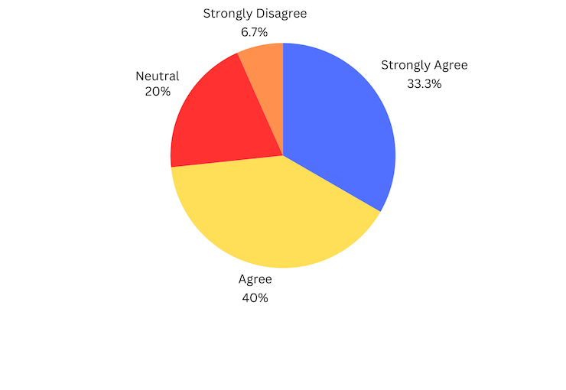

**Figure 14. Survey Responses on Maintainability** The results show that 4 respondents (26.7%) strongly agreed, and 7 respondents (46.7%) agreed. However, 1 respondent (6.7%) was neutral, 1 respondent (6.7%) disagreed, and 2 respondents (13.3%) strongly disagreed, indicating a need for improved maintainability.

The platform is expected to perform well in terms of maintainability, but addressing the concerns of the respondents who disagreed will be essential for improving long-term usability.

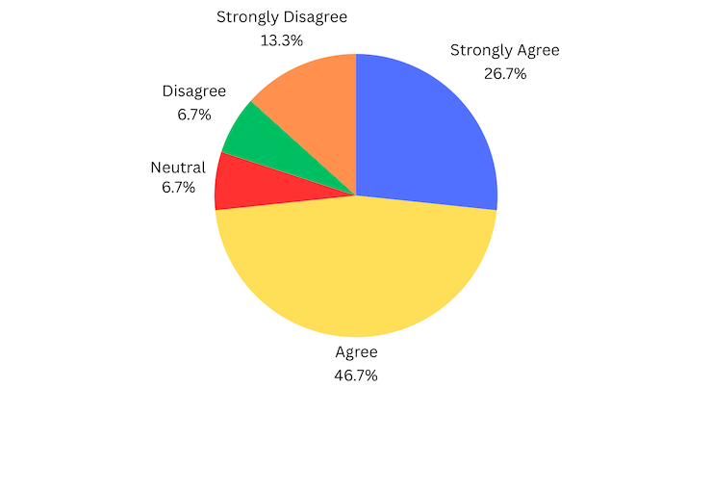

**Figure 15. Survey Responses on Portability**

The majority, 5 respondents (33.3%), strongly agreed, and 6 respondents (40%) agreed. Meanwhile, 3 respondents (20%) were neutral, and 1 respondent (6.7%) strongly disagreed, indicating a need for further enhancements in adaptability.

The platform is expected to be acceptable in terms of portability. However, addressing the concerns of the respondent who disagreed will be important for improving its adaptability.



**CHAPTER IV**

**CONCLUSION AND RECOMMENDATION**

The Medicine Inventory Management System for Small Pharmacies is designed to help small pharmacies manage their inventory, including tracking stock levels and handling customer orders more efficiently. The main purpose of the System is to provide a centralized and efficient solution for managing inventory and transactions while enhancing operational accuracy and improving customer satisfaction.

**Conclusion**

Based on system testing and feedback, the Medicine Inventory Management System effectively addresses the challenges faced by small retail pharmacies by providing real-time inventory tracking, automated stock management, and reporting tools. It ensures accurate stock monitoring, reduces errors, and enhances operational efficiency. Additionally, the system supports data-driven decision-making, helping pharmacies optimize inventory management. Overall, it successfully makes pharmacy operations faster, more organized, and more customer-friendly.

**Recommendation**

The researchers recommend implementing the Medicine Inventory Management System for small pharmacies to improve daily operations and customer service. Proper staff training is essential to ensure that the system's features are fully utilized for efficient inventory management. Additionally, regular system updates are recommended to maintain reliability, enhance security, and adapt to the evolving needs of the pharmacy.

Small pharmacies that implement the Medicine Inventory Management System can automate stock monitoring, reduce medication wastage, and prevent shortages. Utilizing automated

Restocking alerts and system-generated reports optimizes inventory control and minimize financial losses.

Proper training for pharmacy staff is essential for efficient inventory management and sales tracking. Regular refresher sessions ensure accuracy, reduce errors, and improve service efficiency.

Pharmacy administrators should regularly review inventory reports, enforce role-based access control, and schedule system maintenance to improve security, reliability, and operational efficiency. Data-driven insights support better purchasing decisions.

Ensuring maintenance of stock availability and tracking expiration dates improves customer satisfaction and trust in the pharmacy’s services.

**REFERENCES**

* Bautista, A.G. (2020)*. Financial Management of Pharmacies in the City of Cabanatuan, Philippines.* International Journal of Advanced engineering, Management and Science, 6, 405-413.

Retrieved From: [https://scholar.google.com/scholar?hl=en&as_sdt=0%2C5&q=local+](https://scholar.google.com/scholar?hl=en&as_sdt=0%2C5&q=local+studies+in+)

[studies+in+](https://scholar.google.com/scholar?hl=en&as_sdt=0%2C5&q=local+studies+in+)philippines+about+Medicine+Store+Management+Platform+for+Small+pharma

cies&btnG=#d=gs_qabs&t=1726665021647&u=%23p%3DmBx7ZpKb2CEJ

Date Accessed: September 12, 2024

* Cavicchi, C., & Vagnoni, E. (2020). *Sustainable Business Models in Hybrids: A Conceptual Framework for Community Pharmacies’ Business Owner.* 12 (19) 8125, 2020.

Retrieved From: <https://www.mdpi.com/2071-1050/12/19/8125>

Date Accessed: September 11, 2024

* Chu, K., & Martínez Pizano, J.M. (2019). *Replenishment Policies for Retail Pharmacies in Emerging Markets.* Massachusetts Institute of Technology.

Retrieved From: [https://ctl.mit.edu/pub/thesis/replenishment-policies-retail-pharmacies-em](https://ctl.mit.edu/pub/thesis/replenishment-policies-retail-pharmacies-emerging)

[erging](https://ctl.mit.edu/pub/thesis/replenishment-policies-retail-pharmacies-emerging)-markets

Date Accessed: September 11, 2024

* Deschepper, S. (2021). *The centralisation of a hospital pharmacy in a network of hospitals: An operational feasibility study.* Ghent University, Library.

Retrieved From: [https://scholar.google.com/scholar?hl=en&as_sdt=0%2C5&q=example+o](https://scholar.google.com/scholar?hl=en&as_sdt=0%2C5&q=example+of)

[f](https://scholar.google.com/scholar?hl=en&as_sdt=0%2C5&q=example+of)+local+studies+in+capstone+project+about+Medicine+Store+Management+Platform+for

+Small+Pharmacies%22+&btnG=#d=gs_qabs&t=1726663142909&u=%23p%3D-asahyRF

gVEJ

Date Accessed: September 11, 2024

* Doughert, J. (2020). *School Posters Presented at the 121st Virtual Annual Meeting of the American Association of Colleges of Pharmacy.* American journal of pharmaceutical education, 84(6), ajpe8219.

Retrieved From: <https://www.ncbi.nlm.nih.gov/pmc/articles/PMC7334357/>

Date Accessed: September 15, 2024

* Ngo, RPh, MHSS, F. L. U., Gloria, RPh, MPH, GDip, PhD , M. A. J., & Robles, RPh, MPharm, PhD, Y. R. (2024). *Challenges, Adaptive Measures, and Opportunities of Community Pharmacy Practice in the Philippines during the COVID-19 Pandemic.* Acta Medica Philippina.

Retrieved From: [https://actamedicaphilippina.upm.edu.ph/index.php/acta/article/view/](https://actamedicaphilippina.upm.edu.ph/index.php/acta/article/view/9520)

[9520](https://actamedicaphilippina.upm.edu.ph/index.php/acta/article/view/9520)

Date Accessed: September 19, 2024

* Parilla, E., et al. (2022). *Inventory Management Practices and Service Delivery of Healthcare Facilities in Ilocos Norte Philippines.* Logistic and Operation Management Research*,* Vol.1 (1), 16-33.

Retrieved From: [https://www.researchgate.net/publication/361585805_Inventory_Manag](https://www.researchgate.net/publication/361585805_Inventory_Management_P)

[ement](https://www.researchgate.net/publication/361585805_Inventory_Management_P)

[_P](https://www.researchgate.net/publication/361585805_Inventory_Management_P)ractices_and_Service_Delivery_of_Healthcare_Facilities_in_Ilocos_Norte_Philippines

Date Accessed: September 20, 2024

* Plantado, A. N. R., de Guzman, H. J. D., Mariano, J. E. C., Salvan, M. R. A. R., Benosa, C. A. C., & Robles, Y. R. (2023). *Development of an Online Telepharmacy Service in the Philippines and Analysis of Its Usage During the COVID-19 Pandemic.* Journal of pharmacy practice, 36(2), 227–237.

Retrieved From: <https://pubmed.ncbi.nlm.nih.gov/34275381/>

Date Accessed: September 16, 2024

* Reynolds, P., et al. (2020). *Implementation of a Distance‐Based Clinical Capstone Course to Improve Practice‐Related Confidence and Experiential Readiness in Global Pharm.D. Candidates.* JACCP JOURNAL OF THE AMERICAN COLLEGE OF CLINICAL PHARMACY 3(7357) DOI:10.1002/jac5.1244

Retrieved From: [https://www.researchgate.net/publication/340592398_Implementation_of](https://www.researchgate.net/publication/340592398_Implementation_of_a_Dis)

[_a_Dis](https://www.researchgate.net/publication/340592398_Implementation_of_a_Dis)tance-Based_Clinical_Capstone_Course_to_Improve_Practice Related _Confidence

_and_Experiential_Readiness_in_Global_PharmD_Candidates

Date Accessed: Septemeber 15, 2024

* Soliveres, V.L., et al. (2024). *Inventory Management Practices of Small-Scale Pharmacies in the Selected Towns in Cavite: A Marketing Perspective.* Logistic and Operation Management Research, Vol. 3 No. 1.

Retrieved From: [https://www.researchgate.net/publication/381056008_Inventory_](https://www.researchgate.net/publication/381056008_Inventory_Management_P)

[Management_P](https://www.researchgate.net/publication/381056008_Inventory_Management_P)ractices_of_Small Scale_Pharmacies_in_the_Selected_Towns_in_Cavite_A_

Marketing_Perspective

Date Accessed: September 20, 2024

**APPENDICES**

**APPENDIX A**

**Permission Letter for Expert Tester**

January 25, 2025

**Mr. Howel M. Dela Cruz**

IT Administrator

Cadiz District Hospital, Cadiz City, Negros Occidental

Dear Mr. Dela Cruz,

We hope this letter finds you well. As part of the partial fulfillment of the requirements for the Bachelor of Science in Information Technology degree at CEDAR College Inc., Cadiz City, our team is working on a Capstone Project titled “Medicine Inventory Management System for Small Pharmacies” for the second semester of the academic year 2024-2025.

We would like to formally invite you to participate as an expert tester for the User Acceptance Testing (UAT) of our project. Your expertise and feedback will be invaluable in ensuring that the system meets its requirements and is user-friendly.

The system is designed to streamline inventory tracking, minimize stock-related errors, and support better decision-making for small pharmacies. It features real-time inventory monitoring, automated restocking alerts, expiry tracking, and detailed inventory reports to optimize pharmacy operations.

The testing session is scheduled for January 27, 2025, at 9:00 AM in Cadiz City and will take approximately 25 minutes.

We kindly request your confirmation of availability and consent to participate by January 26, 2025. Detailed instructions and system access will be provided prior to the session. Should you have any questions or require further information, please feel free to contact us at nikoabella13@gmail.com, liza38691@gmail.com, or 09707207045.

Thank you for considering our request. We are looking forward to your positive response.

Sincerely,

The Project Team

Christian Dominique A. Abella

Lhenel Ann Jaira L. Gallo

Ana Liza B. Masgon

Richel Mae J. Villa

Approved by: Mr. Howel M. Dela Cruz

IT Administrator

**Permission Letter for Surveyor**

November 22, 2024

**Mr. Jose T. Tajonera**

Owner

JTT Pharmacy

Magsaysay St. Brgy. Zone 3, Cadiz City, Negros Occidental

Dear Mr. Tajonera,

We hope this letter finds you well. As part of our Capstone Project at CEDAR College, Inc., we are surveying to gather insights regarding the Medicine Inventory Management System for Small Pharmacies. This system is designed to help pharmacy admin and staff efficiently manage inventory, monitor stock levels, and prevent shortages, ensuring accurate record-keeping and streamlined inventory control.

With features such as real-time inventory tracking, automated restocking alerts, and detailed stock reports, the platform aims to improve efficiency in pharmacy operations. Your participation in this survey would be highly valuable, as it will help us assess the usability, functionality, and effectiveness of the system.

The survey is scheduled to take place on November 26, 2024, at 9:30 AM. During this time, we will engage 15 selected respondents from your institution, who have been chosen to provide valuable insights.Please be assured that all information you provide will be kept confidential and used solely for the purposes of this research. Your responses will be anonymized and aggregated for analysis.

We kindly request your permission to conduct this survey, which will take approximately 30 minutes to complete. Participation is entirely voluntary, and you may withdraw at any time without consequence.

If you have any questions or concerns regarding the survey. Please feel free to contact us at [nikoabella13@gmail.com](mailto:nikoabella13@gmail.com)/[anngallo@gmail.com](mailto:anngallo@gmail.com)/analizamasgon35@gmail.com/[richelmaevilla@gmail.com](mailto:richelmaevilla@gmail.com). We appreciate your time and cooperation. Thank you for helping us improve our projects.

Sincerely,

THE PROJECT TEAM

Christian Dominique A. Abella

[nikoabella13@gmail.com](mailto:nikoabella13@gmail.com)

09504056580

Lhenel Ann Jaira L. Gallo

[anngallo@gmail.com](mailto:anngallo@gmail.com)

09508564078

Ana Liza B. Masgon

[analizamasgon35@gmail.com](mailto:analizamasgon@gmail.com)

09707207045

Approved by: MR. JOSE T. TAJONERA

Owner

Approved by: DR. WILFREDO D. VILLANUEVA

President

Richel Mae J. Villa

[richelmaevilla@gmail.com](mailto:richelmaevilla@gmail.com)

09630606084

**Permission Letter for Grammarian**

March 17, 2025

**Mr. John Paul V. Sumagaysay**

Teacher

Tortosa Elementary School

Brgy. Tortosa, Manapla, Negros Occidental

Dear Mr. Sumagaysay,

Hope this letter finds you well. We the Bachelor of Science in Information Technology students at Cedar College Inc., currently conducting a research study titled “Medicine Inventory Management System For Small Pharmacies.” Our study aims to develop a structured and efficient system to enhance pharmacy operations by improving inventory tracking, reducing errors, and optimizing stock management.

With this, we are requesting your approval to serve as our Grammarian formally. Your expertise and insights would be invaluable in ensuring the clarity, coherence, and grammatical accuracy of our research work.

We appreciate your time and cooperation. Thank you for helping us improve our projects.

Very truly yours,

Christian Dominique A. Abella

Lhenel Ann Jaira L. Gallo

Ana Liza B. Masgon

Richel Mae J. Villa

Approved by:

John Paul V. Sumagaysay, LPT

Grammarian

**APPENDIX B**

CEDAR College, Inc.

National Highway Cadiz City, Negros Occidental

**RATING SHEET: EXPERT TESTING**

Rating Sheet Based on ISO/IEC 25010 Software Quality Model

Rating Likert Scale:

1 - Poor (Does not meet expectations)

2 - Fair (Meets some expectations but needs improvement)

3 - Good (Meets most expectations)

4 - Very Good (Meets expectations with minor issues)

5 - Excellent ( Exceeds expectations)

|  |  |  |  |
| --- | --- | --- | --- |
| **Attribute** | **Questions** | **Rating (1-5)** | **Comments** |
| **Functionality** | 1. Does the system prevent duplicate medication to guarantee precise inventory management? |  |  |
|  | 1. Are automated alerts for low-stock or expired medications included in the system? |  |  |
|  | 1. Does the system generate detailed inventory reports for tracking stock movement and trends? |  |  |
| **Usability** | 1. Is the user interface easy to understand and navigate? |  |  |
|  | 1. Is the inventory management process straightforward and efficient? |  |  |
| **Reliability** | 1. Does the system run smoothly, without any unforeseen crashes or failures? |  |  |
| **Performance Efficiency** | 1. Is the system efficient in processing transactions and loading data? |  |  |
| **Compatibility** | 1. Can the system work with various devices and operating systems? |  |  |
| **Security** | 1. Is there role-based access control in the system to safeguard sensitive data? |  |  |
|  | 1. Does the system securely store and encrypt sensitive data to prevent unauthorized access? |  |  |

**APPENDIX C**

CEDAR College, Inc.

National Highway Cadiz City, Negros Occidental

**RESEARCH INSTRUMENT EVALUATION FORM**

Name of Respondent: ___________________________________________________________________

*(You may skip this field if you wish to be kept anonymous.)*

Directions:

Please carefully read each question and provide your responses based on your organization's experiences and perceptions. Indicate your level of agreement by selecting the corresponding number and placing a check mark (✓) in the provided box.

Your responses will be kept confidential and used for research purposes only. Should you have any questions or concerns regarding the questionnaire, please do not hesitate to contact us at 09707207045 or via email at analizamasgon35@gmail.com.

Thank you for your cooperation and valuable input! Your insights will help us better understand how a medicine store management platform can address the challenges faced by small pharmacies.

Please continue to answer the following questionnaire:

|  |  |  |  |  |  |
| --- | --- | --- | --- | --- | --- |
|  | (5)  Strongly  Agree | (4)  Agree | (3)  Neutral | (2)  Disagree | (1)  Strongly  Disagree |
| **Functional Suitability** | | | | | |
| 1. I find the system’s features useful for managing pharmacy inventory effectively. |  |  |  |  |  |
| 1. I can easily navigate and use the system without difficulty. |  |  |  |  |  |

|  |  |  |  |  |  |
| --- | --- | --- | --- | --- | --- |
| 1. I can track inventory levels accurately and in real time using the system. |  |  |  |  |  |
| 1. I can efficiently manage both inventory and staff operations using the system. |  |  |  |  |  |
| **Performance Efficiency** | | | | | |
| 1. I experience no delays or slowdowns while using the system for daily pharmacy operations. |  |  |  |  |  |
| **Compatibility** | | | | | |
| 1. **I find the system compatible with existing pharmacy processes and workflows.** |  |  |  |  |  |
| 1. **I can manage various types of medicines and stock variations within the system.** |  |  |  |  |  |
| **Usability** | | | | | |
| 1. **I believe the system meets the expectations of pharmacy administrators and staff.** |  |  |  |  |  |
| 1. **I find the system’s reporting and analytics features helpful for inventory decision-making.** |  |  |  |  |  |
| 1. I receive accurate and real-time stock level updates from the system. |  |  |  |  |  |

|  |  |  |  |  |  |
| --- | --- | --- | --- | --- | --- |
| **Reliability** | | | | | |
| 1. **I can rely on the system to provide accurate inventory tracking and management.** |  |  |  |  |  |
| 1. **I experience minimal disruptions due to technical errors while using the system.** |  |  |  |  |  |
| **Security** | | | | | |
| 1. **I believe the system provides strong security features to protect pharmacy and customer data.** |  |  |  |  |  |
| **Maintainability** | | | | | |
| 1. I find the system easy to maintain, troubleshoot, and update. |  |  |  |  |  |
| **Portability** | | | | | |
| 1. **I can easily adapt the system for use in different pharmacy locations or devices.** |  |  |  |  |  |

**APPENDIX D**



**CEDAR COLLEGE, INC.**

**National Highway, Cadiz City, Negros Occidental**

GRAMMARIAN CERTIFICATE

This is to certify that the undersigned has viewed and examined all the pages of the Capstone Project entitled **“Medicine Inventory Management System for Small Pharmacies”** developed by **Christian Dominique A. Abella, Lhenel Ann Jaira L. Gallo, Ana Liza B. Masgon, and Richel Mae J. Villa** aligned with the set of structural rules that govern the composition of sentences, phrases, and words in the English language.

Signed this 17th day of March 2025 at Manapla, Negros Occidental.

**JOHN PAUL V. SUMAGAYSAY, LPT**

Grammarian, MAPEH Teacher

**APPENDIX E**

**FROND-END SOURCE CODE**

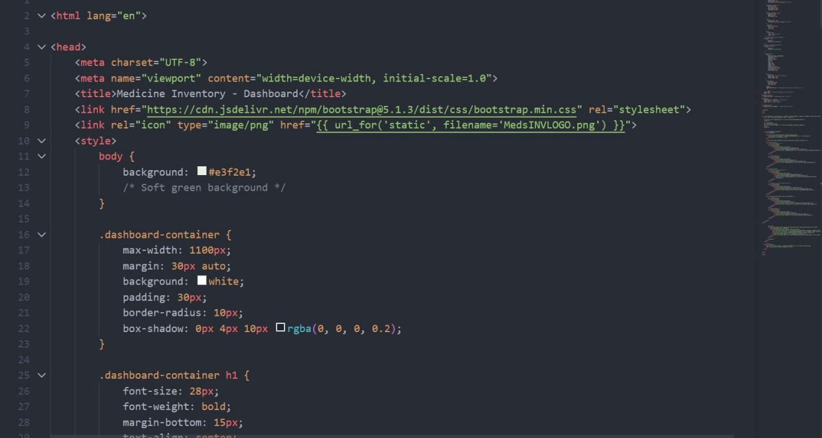

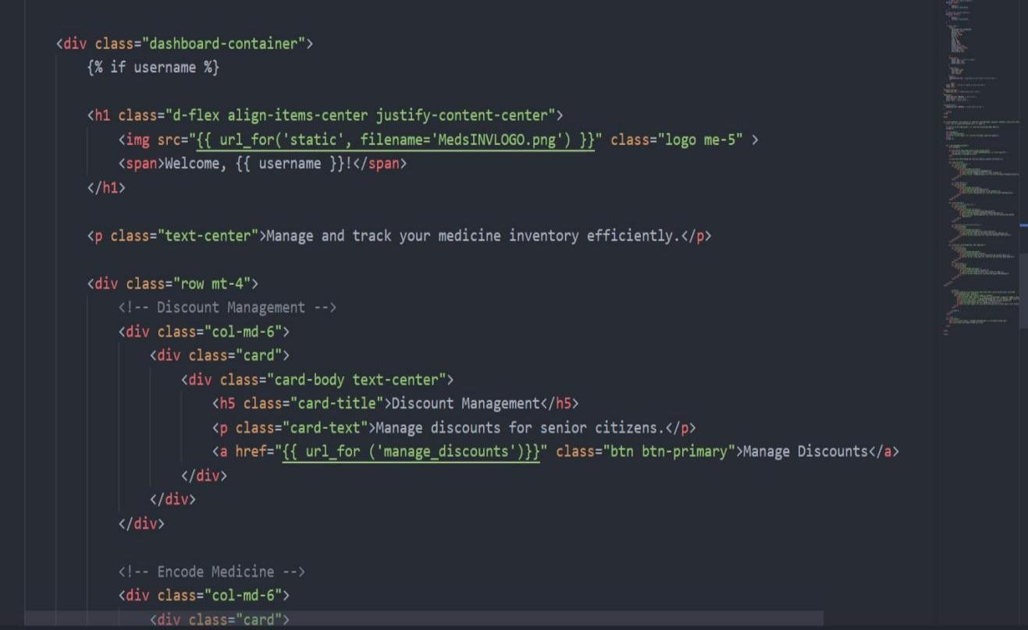

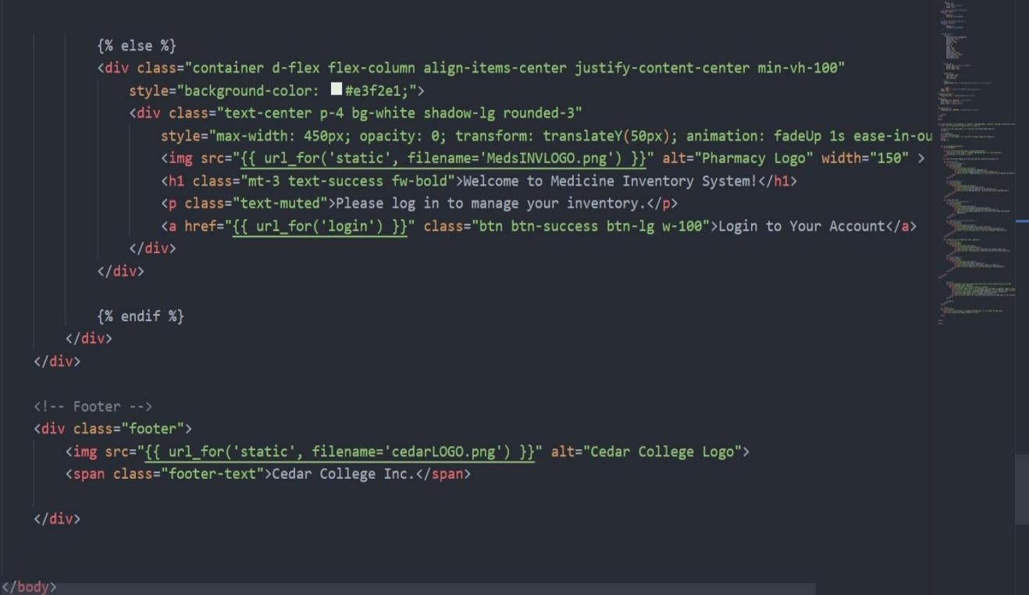

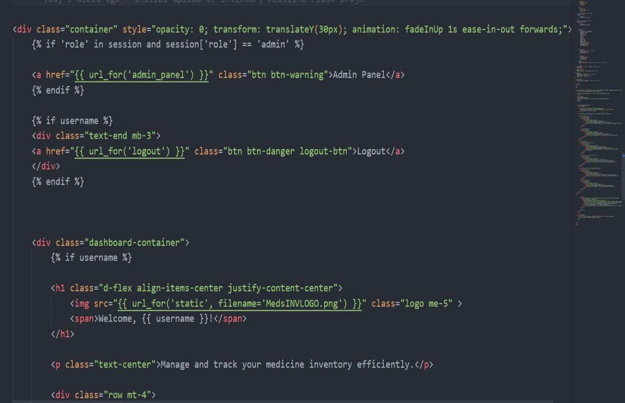

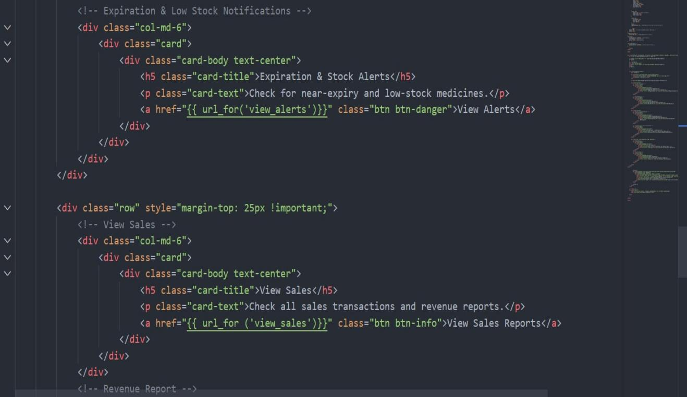

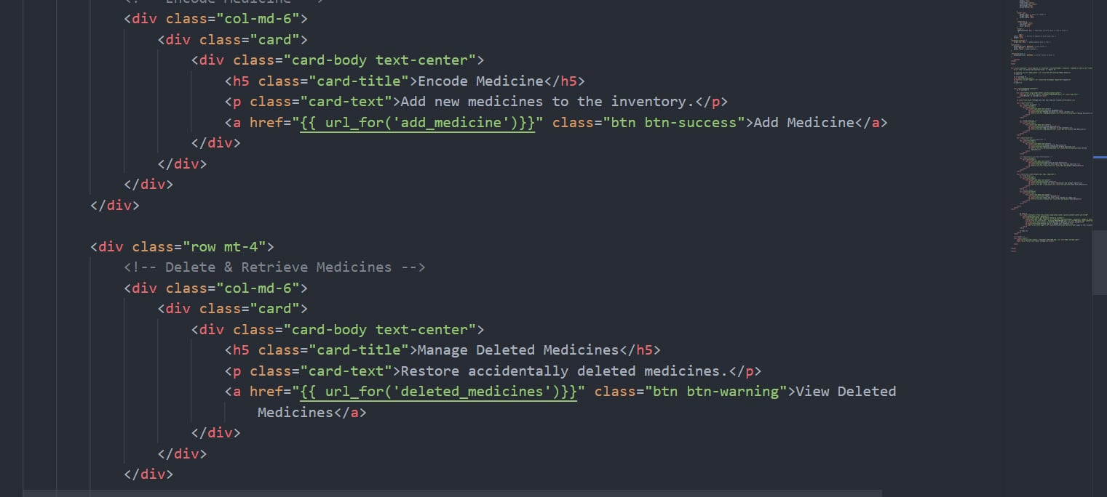

**BACK-END SOURCE CODE**

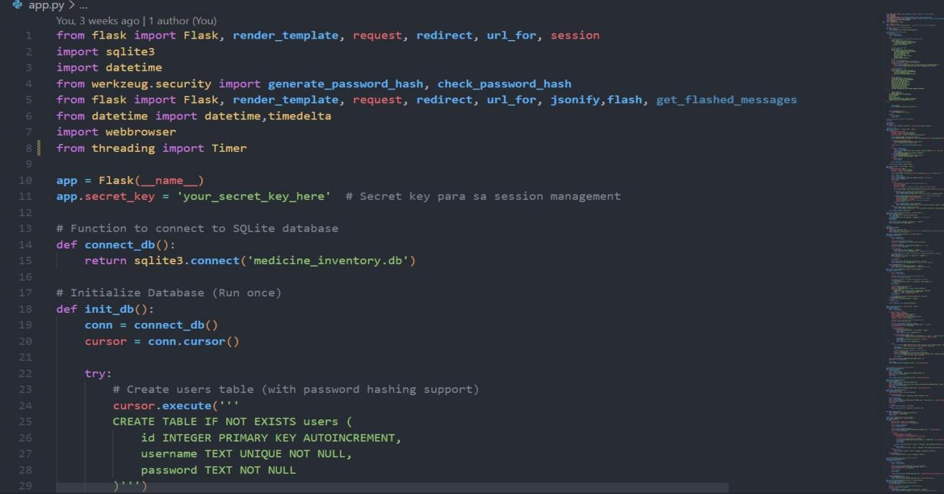

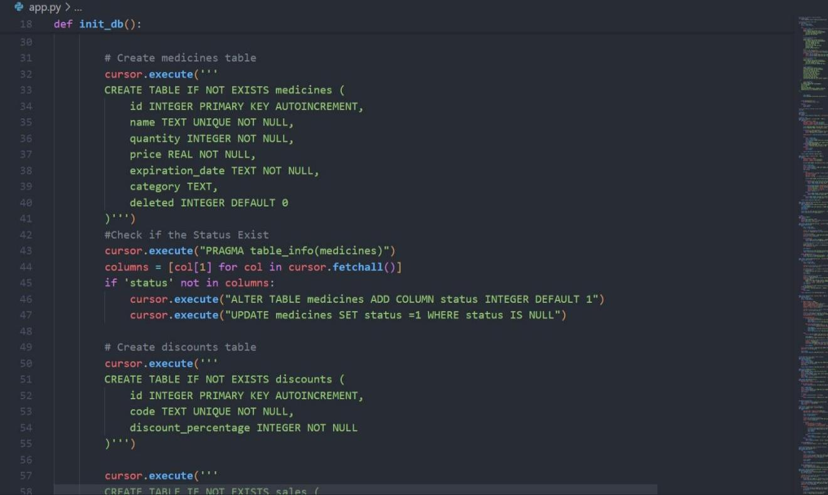

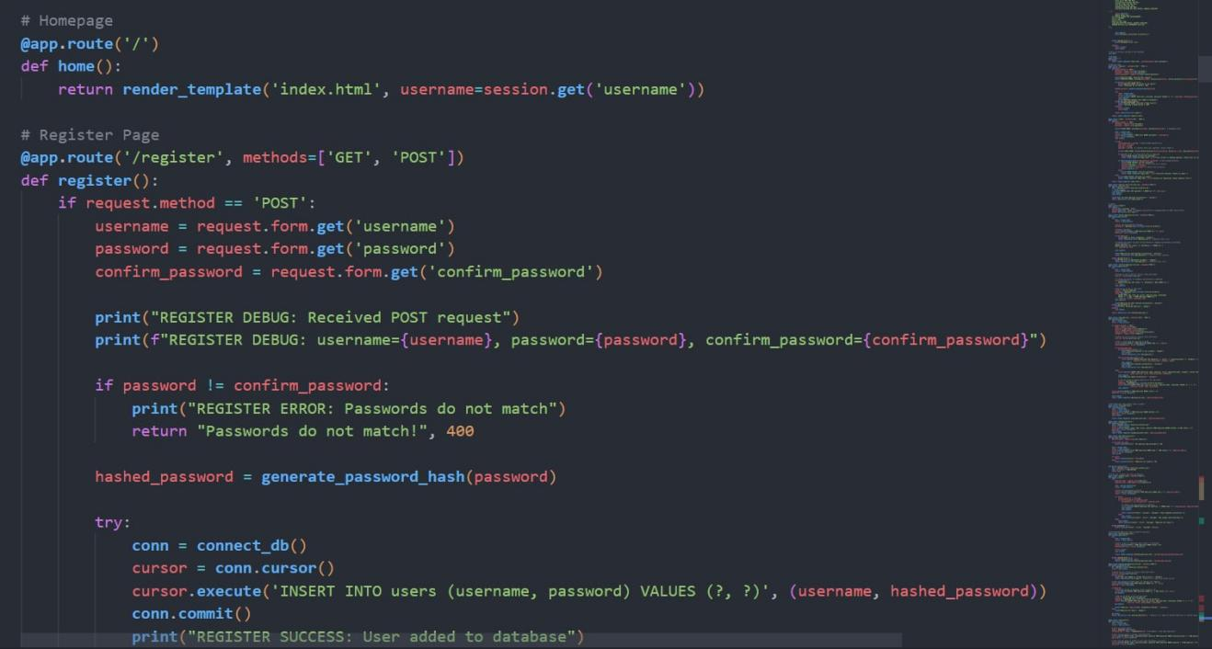

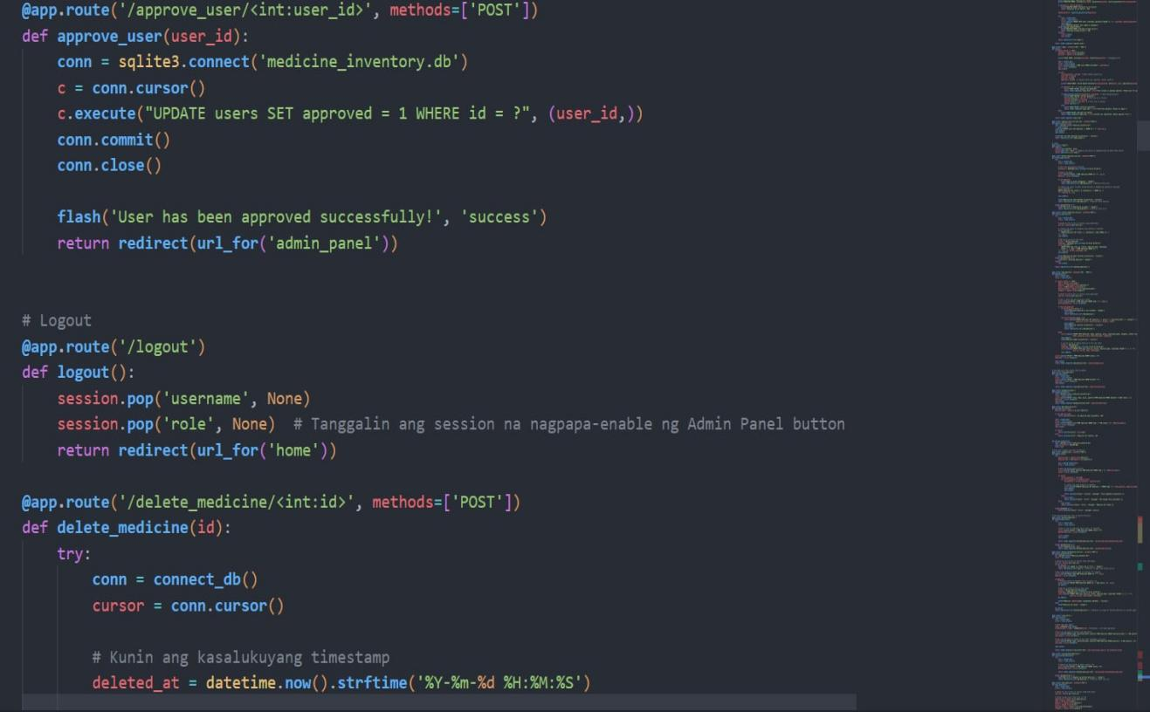

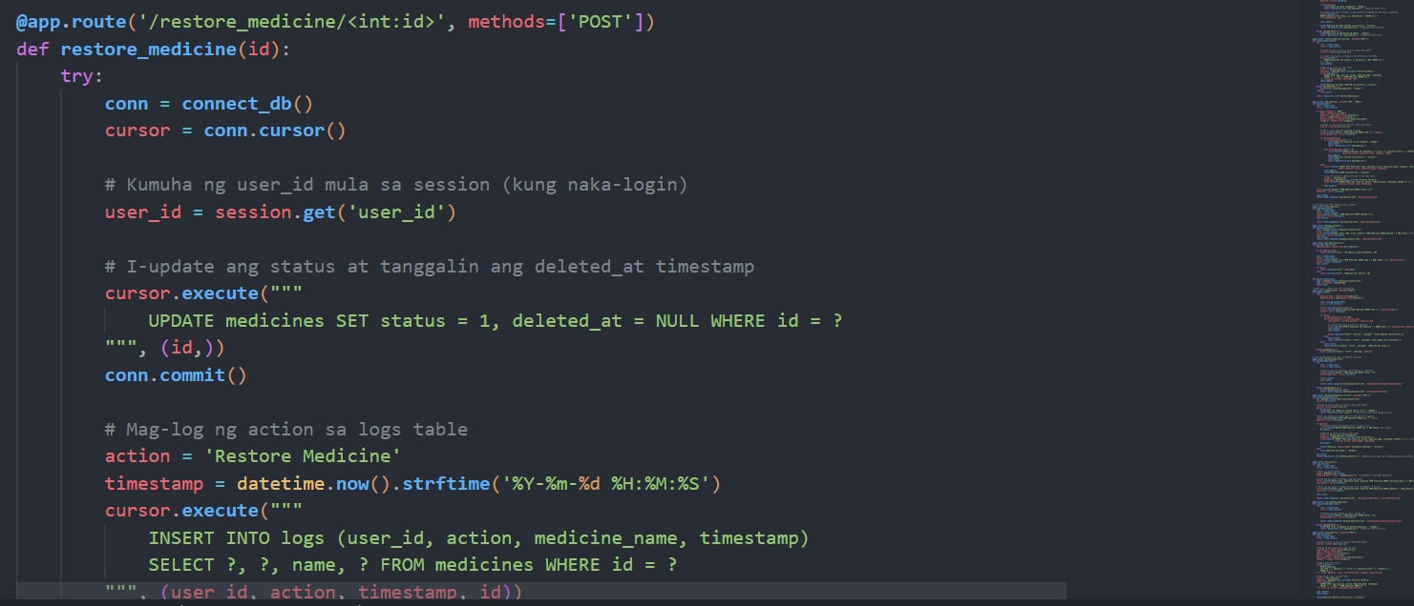

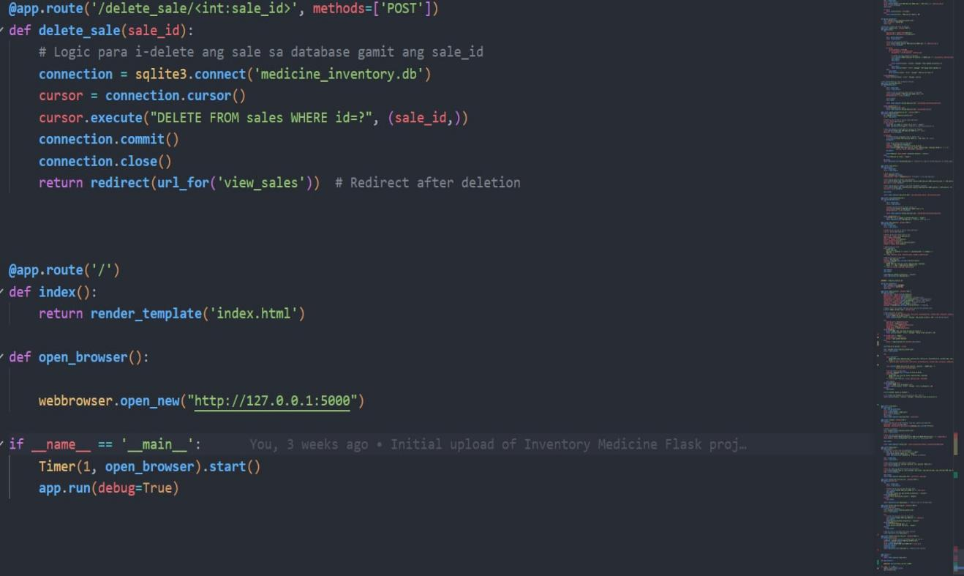

**APPENDIX F**

**MEDICINE INVENTORY MANAGEMENT SYSTEM FOR SMALL PHARMACIES**



**version 1.9**

Christian Dominique A. Abella

Lhenel Ann Jaira L. Gallo

Ana Liza B. Masgon

Richel Mae J. Villa

March 2025

**USER MANUAL**

**Introduction**

* 1.1 Purpose of the Manual

This user manual serves as a guide for using the Medicine Inventory System for Small Pharmacies. It provides step-by-step instructions on how to install, configure, and operate the system efficiently.

* 1.2 System Overview

The Medicine Inventory System is designed to help small pharmacies manage their stock, track sales, and apply discounts to eligible customers. Key features include:

Medicine Management - Add, update, delete, and restore medicine records.

Discount Management - Automatic 20% discount for Senior Citizens and PWDs.

Inventory Alerts - Notifications for low-stock and near-expiry medicines.

Sales & Revenue Reports - View and export sales data for tracking revenue.

* 1.3 Target Users

This system is intended for:

Pharmacy Owners/Admins - Can manage user accounts and oversee inventory.

Pharmacy Staff - Can add medicines, process sales, and apply discounts.

* 1.4 System Requirements

The system runs as a standalone PC application (.exe) and requires:

- Operating System: Windows 10/11

- Processor: Intel Core i3 or higher

- RAM: 4GB minimum (8GB recommended)

- Storage: At least 500MB free space

- Database: SQLite (included in the system)

* 1.5 Getting Started

To start using the system, follow these steps:

Install the system - Follow the installation guide in Section 2.

Admin approval - New users must be approved by the Admin.

Log in - Once approved, log in using your credentials.

Navigate the Dashboard - Access system features such as inventory, sales, and discounts.

**Installing the Software**

* 2.1 Installation Guide

- To install the Medicine Inventory System:

- Download the installer (.exe) file.

- Double-click the installer and follow the on-screen instructions.

- Choose the installation location and complete the setup.

- Once installed, open the application and log in.

* 2.2 System Login & Registration

- New users must register and wait for Admin approval before logging in.

- Existing users can log in using their username and password.

* 2.3 User Roles & Permissions

- Admin: Full access, can approve users, manage inventory, view sales, and restore deleted items.

- Staff: Can add medicines, process transactions, and apply discounts but cannot approve new users.

- User Interface Walkthrough

* 3.1 Login Page

- Enter your username and password.

- Click Login to access the system.

* 3.2 Dashboard

After logging in, the Dashboard displays:

Total Medicines - Count of all medicines in stock.

Low-Stock Alerts - Medicines that need restocking.

Near-Expiry Alerts - Medicines that will expire soon.

Total Sales - Daily revenue summary.

View deleted medicine - Deleted medicine can be restored.

* 3.3 Medicine Management

To add medicine:

- Click Add Medicine.

- Enter details: Name, Batch Number, Expiry Date, Quantity, Price.

- Click Save to add the medicine to inventory.

To edit medicine details:

- Go to the Medicine List.

- Click Edit next to the medicine name.

- Update the necessary fields and click Save.

To delete medicine:

- Click Delete next to a medicine name.

- Confirm deletion. Deleted items can be restored later.

To restore deleted medicine:

- Go to the Deleted Medicines page.

- Click Restore next to the medicine name.

**System Features & Usage**

* 4.1 User Authentication

- The system requires users to log in before accessing features.

- Admins approve new users before they can use the system.

* 4.2 Data Entry & Management

- Users can add, edit, delete, and restore medicine records.

- The inventory is updated automatically when sales are made.

* 4.3 Report Generation

- Sales reports are generated daily, weekly, and monthly.

- Reports can be exported to pdf format for external use.

* 4.4 Discount Management

- Senior Citizens and PWDs get an automatic 20% discount.

- The discount is applied during checkout and is reflected in the receipt.

**Settings & Configuration**

* 5.1 User Account Settings

- Admins can reset passwords and approve new users.

* 5.2 System Preferences

- Admins can enable or disable certain features such as notifications and backup options.

* 5.3 Admin Controls

The Admin Panel allows monitoring of user activities, including:

- Who added, edited, or deleted medicines.

- Who applied discounts.

* 5.4 Error Handling & Troubleshooting

- Incorrect Login: Ensure username and password are correct.

- System Crash: Restart the application and check for updates.

- Data Loss: Restore data from the latest backup.

**Common Errors & Solutions**

* 6.1 FAQs

Q: How do I reset a forgotten password?

A: Admin can reset it from the Admin Panel.

Q: Why can’t I log in after registering?

A: Your account needs Admin approval before you can log in.

* 6.2 Data Security & Backup

- The system automatically saves data to the SQLite database.

- Regular manual backups are recommended to prevent data loss.

**Data Storage & Encryption**

* 7.1 Backup & Restore Procedures

To create a backup:

- Go to Settings > Backup.

- Click Export Database and save the file.

To restore a backup:

- Click Import Database in the Backup section

- Select the backup file and restore data

- Keyboard Shortcuts

- Coltrol C - copy medicine name

- Control V - copy the medicine name

**Contact & Support Information**

For further assistance, contact:

Email: nikoabella13@gmail.com.com

Phone: +639504056580

**APPENDIX G**

**CURRICULUM VITAE**



Full Name: Abella, Christian Dominique A.

Position/Role: Back-End Developer

Age: 23

Gender: Male

Date of Birth: January 1, 2002

Place of Birth: Quezon city

Adress: Hda. Bayabas 3. Brgy. Daga Cadiz City, Neg. Occ.

Contact Number: 09504056580

Email: [nikoabella13@gmail.com](mailto:nikoabella13@gmail.com)

Full Name: Gallo, Lhenel Ann Jaira L.

Position/Role: Hardware Technician

Age: 24

Gender: Female

Date of Birth: May 23, 2000

Place of Birth: Silay City

Adress: Brgy. Tiglawigan, Cadiz City, Neg. Occ.

Contact Number: 09508564078

Email: Jairalhenelgallo@gmail.com

Full Name: Masgon, Ana Liza B.

Position/Role: Frond-End Developer

Age: 21

Gender: Female

Date of Birth: April 23, 2003

Place of Birth: Manapla

Adress: Emmanuel Homes Brgy. Sta. Teresa, Manapla, Neg. Occ.

Contact Number: 09707207045

Email: liza38691@gmail.com

Full Name: Villa, Richel Mae V.

Position/Role: Project Manager

Age: 21

Gender: Female

Date of Birth: June 9, 2009

Place of Birth: Manapla

Adress: Hda. Encarnacion Brgy. Purisima, Manapla, Neg. Occ.

Contact Number: 09630606084

Email: richelmaevilla@gmail.com